System Analysis & Design Viva Preparatory Questions

C O N T E N T S
System Analysis & Design Viva Preparatory Questions 1
System Analysis and Design Interview Topics for Freshers 8
1. Information System(IS) 8
Six Major Components of Information System: 8
2. Characteristics(Properties) of a System Analysis 8
3. Classification of System Analysis 9
4. Distributed Systems 9
Advantages of Distributed Systems: 9
The five layers of Distributed System architecture are: 10
5. System Analysis and Design 10
Approaches to Development 10
6. System Analyst 10
Role of a System Analyst 10
Duties of a System Analyst 11
Qualifications of a System Analyst 11
7. System Development Life Cycle(SDLC) 11
SDLC consists of mainly seven steps or phases. These are: 11
8. Documentation of Systems 12
The steps involved in the process of documentation are: 12
9. System Requirements Specification(SRS) 12
Characacteristics of a SRS 12
Structure or Outine of a SRS Document: 12
System Design Specification or Software Design Specification 12
10. Fact Finding Techniques or Information Gathering Techniques 13
Interviews 13
Advantages of Interviews 13
Disadvantages of Interviews 13
Feasibility Study 13
Cost Benefit Analysis 14
11. Modular and Structured Design 14
Design Principles 14
Guidelines for good design are: 14
Coupling 15
Cohesion 15
12. Form Design 15
Criteria for form design 15
13. Report Design 16
Types of Output for Report Design 16
Criteria for report design 16
User Interface Design 16
14. Process Modeling or Data Flow Diagram (DFD) 16
The components of a Data Flow Diagram(DFD) are: 16
here are the notations for the components: 17
15. CASE Tools – Computer-Aided Software Engineering Tools 17
Use of CASE Tools: 17
Role of CASE Tools: 18
Advantages of CASE Tools: 18
Types or Components of CASE Tools: 18
16. Implementation of Systems 19
System Testing 19
Converting Old System to the New System: 19
17. Maintenance of Systems 20
Different Maintenance Activities 20
18. Audit of Computer Systems 20
Responsibility and Authority of the System Auditor: 20
Factors Audited by IS Auditor: 21
Some Important Terms 21
Disaster Recovery Plan 21
Techniques applied for contingency situations are: 21
Contingency Planning Steps: 22
19. Viruses 22
20. Concurrent Audit 22
Concurrent Audit Techniques 22
21. Different Kinds of Information Systems 23
Management Information System (MIS) 23
Transaction Processing System (TPS) 23
Decision Support System (DSS) 23
Expert System 23
System Design Interview Questions and Answers [2025] 24
1. Design a URL Shortening Service (TinyURL) 24
Things to discuss and analyze: 24
2. Design YouTube/Netflix (A Global Live Video Streaming Service) 25
Things to discuss and analyze: 25
3. Design Facebook Messenger or WhatsApp (A Global Chat Service) 25
Things to discuss and analyze: 25
4. Design Quora/Reddit/HackerNews (A Social Network + Message Board Service) 25
Things to discuss and analyze: 25
5. Design Search Typeahead (Autocomplete) 26
Things to discuss and analyze: 26
6. Design Dropbox/Google Drive/Google Photos (A Global File Storage and Sharing Service) 26
Things to discuss and analyze: 26
7. Design a Web Crawler 26
Things to discuss and analyze: 26
8. Design Facebook, Twitter, or Instagram. 27
Features to be considered: 27
Things to analyze: 27
9. Design Uber or Lyft (A Ride-Sharing Service) 27
Things to analyze and discuss: 27
10. Design an API Rate Limiter(Github) 27
Things to analyze and discuss: 28
11. Design a Notification System (Push Notifications) 28
Things to analyze and discuss: 28
Conclusion 28
System Analysis Design -Chapter 3 - Information Gathering 29
Learning Goals 29
Information Gathering Strategies 29
Information Sources 29
Information Gathering Tools 29
Review of Literature, Procedures and Forms 29
On Site Observation 30
Problems in On Site Observation 30
Interviews 30
Planning an Interview 30
Interviewing Technique 30
Use of Questionnaires 31
Advantages of Questionnaires 31
Types of Interviews and Questionnaires 31
The Unstructured Alternative 31
The Structured Alternative 31
Closed Questions 31
Information Gathering other Methods 32
20 System Analysis and Design Interview Questions and Answers – CLIMB 33
1. What is System Analysis and Design? 33
2. What are the different phases in a typical system development life cycle? 33
3. Can you explain what information systems architecture is? 33
4. How can data flow diagrams be used to model business processes? 33
5. What do you understand by a use case diagram? How can it help with system analysis? 33
6. What is the difference between an activity, sequence, and state diagram? 33
7. Can you explain what a class diagram is and how it relates to object-oriented programming languages like Java and C++? 34
8. What’s your understanding of functional requirement specification documents? 34
9. What is the purpose of a context diagram? 34
10. What is the significance of a Gantt chart? 34
11. What is database design? Why is it important for a software analyst to know about it? 34
12. What factors should be considered when designing a database schema? 34
13. How would you deal with legacy code that needs to be refactored or rewritten? 35
14. What is the best way to reduce complexity when analyzing a large code base? 35
15. What tools do you use to analyze source code? 35
16. What is the importance of using agile methodologies while performing software analysis tasks? 35
17. What is the difference between functional and non-functional requirements? Give some examples of each type of requirement. 35
18. Is there any difference between SDLC and SADLC? If yes, then what is it? 35
19. What is the most common mistake made by junior software analysts? Do you think its something that can be avoided? 36
20. In your opinion, what is the most difficult part of the system analysis process? 36
5 Information Systems Analyst Interview Questions and Answers 37
1.1. Describe a situation where you had to analyze a large dataset to derive actionable insights. 37
Introduction 37
How to answer 37
What not to say 37
Example answer 37
1.2. How do you prioritize tasks when working on multiple projects simultaneously? 37
Introduction 37
How to answer 37
What not to say 38
Example answer 38
2.1. Can you describe a time when you successfully implemented a new information system in an organization? 38
Introduction 38
How to answer 38
What not to say 38
Example answer 38
2.2. How do you approach gathering requirements from stakeholders for a new system? 39
Introduction 39
How to answer 39
What not to say 39
Example answer 39
3.1. Can you describe a complex information system project you managed and how you ensured its success? 39
Introduction 39
How to answer 39
What not to say 40
Example answer 40
3.2. How do you approach data security and compliance in information systems? 40
Introduction 40
How to answer 40
What not to say 40
Example answer 40
3.3. Describe a time when you had to adapt to a significant change in technology or process within your organization. 41
Introduction 41
How to answer 41
What not to say 41
Example answer 41
4.1. Can you describe a project where you implemented a new information system that significantly improved operations? 41
Introduction 41
How to answer 41
What not to say 42
Example answer 42
4.2. How do you ensure data integrity and security in the information systems you manage? 42
Introduction 42
How to answer 42
What not to say 42
Example answer 42
5.1. Can you describe a time when you implemented a new information system that significantly improved operational efficiency? 43
Introduction 43
How to answer 43
What not to say 43
Example answer 43
5.2. How do you ensure the security and compliance of information systems within your organization? 43
Introduction 43
How to answer 43
What not to say 44
Example answer 44
System Design Interview Questions 45
System Design Interview Questions for Freshers 45
1. What is CAP theorem? 45
2. How is Horizontal scaling different from Vertical scaling? 46
3. What do you understand by load balancing? Why is it important in system design? 47
4. What do you understand by Latency, throughput, and availability of a system? 48
5. What is Sharding? 48
6. How is NoSQL database different from SQL databases? 49
7. How is sharding different from partitioning? 49
8. How is performance and scalability related to each other? 50
9. What is Caching? What are the various cache update strategies available in caching? 50
10. What are the various Consistency patterns available in system design? 52
11. What do you understand by Content delivery network? 53
12. What do you understand by Leader Election? 54
13. How do you answer system design interview questions? 54
14. What are some of the design issues in distributed systems? 54
System Design Interview Questions for Experienced 55
1. Design Uber, Ola or Lyft type of systems. 55
Information Design Interview Questions and Answers 56
12 Systems Analyst interview questions and answers (upwork) 68
1. Can You Describe Your Experience with Business Process Modeling and Analysis? 68
2. How Do You Identify and Communicate System Requirements to Technical Teams? 68
3. Can You Describe a Time When You Identified a System Issue and Proposed a Solution? 68
4. How Do You Stay Current with Technology Trends and Best Practices? 69
5. Can You Explain the Importance of Stakeholder Management in Your Role as a Business Systems Analyst? 69
6. How Do You Prioritize Multiple Projects or Requests with Competing Deadlines? 69
7. Describe a Challenging Project You've Worked On and How You Overcame the Challenges. 70
8. How Do You Approach User Acceptance Testing (UAT) for New Systems or Enhancements? 70
9. What is your experience with Methodologies, Agile or Waterfall? 70
10. How Do You Handle Scope Creep or Changing Requirements During a Project? 71
11. How Do You Balance Technical Expertise with Business Acumen in Your Role as a Business Systems Analyst? 71
12. What Do You Enjoy Most About Your Work as a Business Systems Analyst? 71
45 system design interview questions to ask systems designer applicants 72
Basic systems design interview questions to ask junior applicants 72
Table of contents 73
Basic systems design interview questions to ask junior applicants 73
5 critical basic system design interview questions and answers 74
Table of contents 75
Basic systems design interview questions to ask junior applicants 75
5 critical basic system design interview questions and answers 76
1. Which systems design skill are you most proud of? 76
2. Which systems design skills do you need to develop? 77
3. Explain what systems design is 77
4. Which factors are the most important for designing a system perfectly? 77
5. Name three design issues you may encounter in distributed systems 77
Table of contents 78
Basic systems design interview questions to ask junior applicants 78
5 critical basic system design interview questions and answers 79
1. Which systems design skill are you most proud of? 81
2. Which systems design skills do you need to develop? 81
3. Explain what systems design is 81
4. Which factors are the most important for designing a system perfectly? 81
5. Name three design issues you may encounter in distributed systems 82
Advanced systems design interview questions to ask senior applicants 82
5 critical advanced systems design interview questions and answers 83
1. Name some best practices for debugging and testing systems 83
2. Which methods are best for addressing optimization and high availability? 83
3. Name four types of documentation related to systems design 83
4. Which factors are important when designing infrastructures for large apps? 83
5. Name a load-balancing method that optimizes a system’s performance 84
5 systems design interview questions and answers related to skills and abilities 84
1. Is communication important for systems designers? Explain your answer 84
2. How is leadership experience key for systems designers? 84
3. How have problem-solving skills made systems design projects easier? 84
4. Why is programming knowledge important for systems designers? 85
5. How has attention to detail helped you during systems design projects? 85
Links avoided 86
All Links 86

---
Recommended by Mahbub Sir

System Analysis and Design Interview Topics for Freshers

System Analysis is the "what" before the "how" in system design. It provides the essential roadmap for crafting a system that is both effective and efficient in solving the intended problem. "Imagine you're building a dream house. You wouldn't start hammering nails without a detailed blueprint, right?"The same goes for software development."
System analysis is the blueprint, while system design translates it into the actual system.

1. Information System(IS)
Information systems are integral to system design, shaping the architecture, data management, user interaction, and development process.
By carefully considering the role of IS, system designers can create systems that are robust, user-friendly, and meet the needs of their intended users.

Six Major Components of Information System:
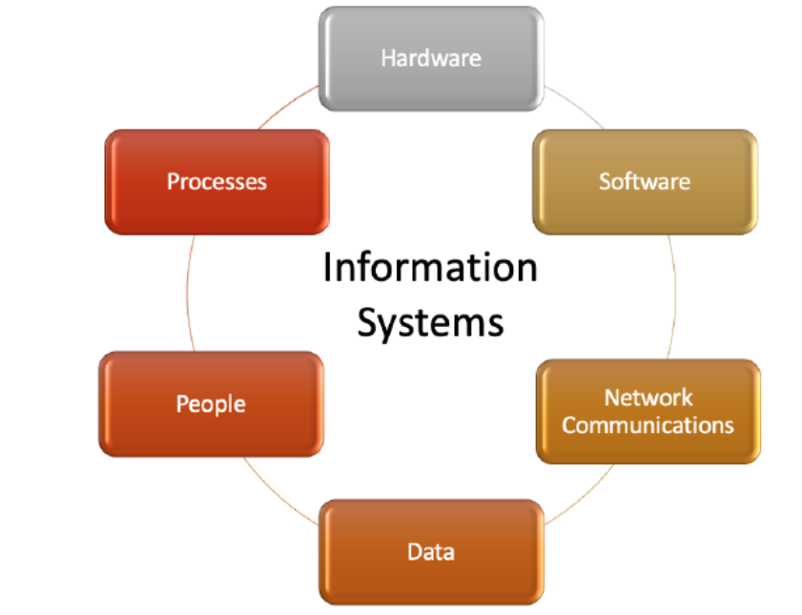

2. Characteristics(Properties) of a System Analysis
Properties of a system analysis are:
- Organization - Arrangement of components.
- Interaction - Procedure in which each component functions with other components.
- Interdependence - Dependence of one component on another component.
- Integration - Refers to how a system is tied together.
- Central Objective - The objective for the system to achieve.

3. Classification of System Analysis
Classification of system analysis is as follows:
- Formal System - Planned or Documented procedures. For example - Scheduled meetings.
- Informal System - Not described by Procedures. For example - Sales orders procession system through telephone call
- Physical System - Tangible entities that may be static or dynamic. For example - Computer.
- Abstract System - Conceptual Entities. For Example - Company.
- Open System - Receives input and provides output to the environment. For example - Organisation.
- Closed System - Isolated from environmental influences. it is rare in reality
- Manual System- Require human intervention. For Example - The railway ticket counter
- Automated System - Does not Require human intervention. For example - Traffic control system
Real Time Systems - Interactive processing system with severe time limitations. There are two types of Real Time systems. They are:
- Hard Real Time Systems complete critical tasks on time. For example - Radar System
- Soft Real Time Systems are the less restrictive type of real time systems. For example - Industrial Control System
System Users - The people who use information systems.
- Internal Users - Employees of the business
- External Users - Customer of the business

4. Distributed Systems
Distributed Systems: Data, Process and Interface components are distributed to multiple locations in computer networks.

Advantages of Distributed Systems:
- Resource Sharing - Allows multiple computers to share resources such as files, printers, and processing power.
- Computation Speedup - Faster execution of tasks as computations are carried out simultaneously.
- Reliability - If one component or node fails, the system can continue functioning using alternative resources.
- Communication - Facilitate efficient communication between nodes, allowing them to exchange information seamlessly.

The five layers of Distributed System architecture are:
- Presentation Layer is the actual user interface and helps in input & output operations.
- Presentation Logic layer include processing for establishing user interface.
- Application Logic Layer includes all the logic and processing for support the application
- Data Manipulation Layer Includes all the commands and logic for storing and retrieving data.
- Data Layer is actual stored data in the database

5. System Analysis and Design
- System Analysis - This involves studying the requirements of either the existing system or a new system in order to design an effective system.
- System Design - Involves the process of creating a well-structured system with careful consideration of objectives and requirements.

Approaches to Development
Attempts to make system development less of an art and more of a science usually referred to as engineering techniques, are applied to system development. Techniques are:
- Prototyping - Designing and building a scaled-down but fundamental version of a desired system is known as prototyping.
- Joint Application Design(JAD) - Users, managers, and system developers are brought together for a series of intensive structured meetings run by a JAD session leader.
- Participatory Design(PD) - Each user has an equal share in determining system requirements and in approving system design

6. System Analyst
A System Analyst is an individual responsible for analyzing requirements and designing information systems.

Role of a System Analyst
- Change Agent - Introduce changes to the user organization.
- Investigator and Monitor - Investigate the existing system to find the reasons for its failure and also monitor programs about time, cost and quality.
- Architect - Creates a detailed physical design of candidate systems.
- Psychologist - Interprets user thoughts, and assesses their behaviour to find facts about the system.
- Motivator - Effective user training and proper motivation to use the system.
- Intermediary - Diplomacy in dealing with people for acceptance of the system.

Duties of a System Analyst
- Defining Requirements -Understand the user's requirements.
- Prioritising Requirements by Consensus - Meeting with all other users and arriving at a consensus.
- Analysis - Analyses the working of the current system
- Solving Problems - Identify alternative solutions and select the best solution for a particular problem.
- Drawing up Functional Specifications - Precise and detailed specifications so it can be used by system implementers.
- Designing Systems - After specifications are accepted, the analyst designs the system
- Evaluating System - Evaluate a system after it has been in use for a reasonable time.

Qualifications of a System Analyst
- Analytical Skills - Includes system study, organizational knowledge, problem identification, problem analysis and problem solving.
- Technical Skills - Includes knowledge of Programming languages, OS, DBMS, different type of computer
- Management Skills - Includes resource management, project management, risk management, change management
- Interpersonal Skills - Includes communication skills, working alone as well as in a team, facilitating groups, and managing expectations.

7. System Development Life Cycle(SDLC)
SDLC, or Software Development Life Cycle, is a common set of steps for system development used by many organizations.

SDLC consists of mainly seven steps or phases. These are:
- Project Identification and Selection - Identifying the need for a new or improved system and selecting priorities for the system.
- Project Initiation and Planning - Detailed work plan, specification of system scope and high-level system requirements.
- Analysis - Includes study of requirements and feasibility.
- Logical Design - it is not tied to any specific hardware and system software platform.
- Physical Design - Turning logical design into technical specifications.
- Implementation - Includes coding, testing and installation.
- Maintenance - Making changes that users ask for and modifying the system to reflect and support changing business conditions.

8. Documentation of Systems
Documentation - It is the process of communicating about the system.

The steps involved in the process of documentation are:
- Collection of source material for documentation
- Documentation Plan
- Review of Plan
- Creation of Document
- Testing of Document
- Maintain Document

9. System Requirements Specification(SRS)
it is a set of complete and precisely stated properties along with the constraints of the system that the software must satisfy.

Characacteristics of a SRS
- Unambiguous - Every requirement stated has only one interpretation.
- Complete - It should include all functions and constraints intended by the system user.
- Realistic & Achievable - The requirements should be realistic and achievable with current technology.
- Verifiable & Consistent - No requirement should conflict with any other requirement.
- Modifiable - Any necessary changes to requirements can be made easily.
- Traceable - The origin of each requirement must be clear.
- Useful - The SRS must address the needs of the operation and maintenance phase.

Structure or Outine of a SRS Document:
- Introduction - Includes its purpose, scope, and objectives.
- Informative description about the system - Includes Information flow representation, Description of sub-systems and System Interface, and the problems it aims to solve.
- Functional Description of the system -Includes Restrictions, limitations, Performance, Design constraints, and software diagram.
- Test and validation criteria - Includes Performance limitations, and expected software response.
- Glossary - Definition of all technical or software-specific terms used in the document.
- Bibliography - Reference of all documents related to the software.

System Design Specification or Software Design Specification
it gives a complete understanding of the details of each component of the system, and its associated algorithms, etc.

10. Fact Finding Techniques or Information Gathering Techniques
Techniques used for collecting data related to the existing system to learn the function of the existing system. Various fact-finding techniques are:
- Interview - This important fact-finding technique, where the system analysts gather information from individuals through face-to-face interaction.
- Group Discussions - A group of staff members are invited by system analysts from different wings for discussion.
- Site Visits - The system analysts visit sites to get information on the working of the system.
- Presentations - The customer makes a presentation of the existing system or about the organisation.
- Questionnaires - Special purpose documents that allow the analyst to collect information and opinions.

Interviews
The steps involved in the interview are Introduction, Asking Questions, Recording the interview, and Doing a final check. There are two types of interviews:
- Structured - There is a specific set of questions to be asked to an interviewee.
- Unstructured - No specific set of questions only a general goal or subject in mind.

Advantages of Interviews
- Get individual's views
- Better clarity of the problem
- The interviewee responds freely and openly

Disadvantages of Interviews
- Very time consuming
- Depends on the system analyst's interpersonal skills
- May be impractical due to the location

Feasibility Study
Consists of activities which determine the existence of the scope of developing an information system for the organisation. There are different feasibility study like
- Technical Feasibility - Concerned with hardware, software and expertise required for the development of the system.
- Operational Feasibility - All about problems that may arise during operations like useful information, response time, Accuracy, Security, and Efficiency.
- Economical Feasibility - Judging whether the possible benefits of solving the problem is worthwhile or not.
- Legal Feasibility - Consideration of copyright law, labour law, antitrust legislation, regulation, etc.

Cost Benefit Analysis
It involves analysing the costs associated with implementing and operating a system against the expected benefits it will bring. Different costs are
- Cost of human resources - Salaries of system analysts, software engineers, programmers, data entry operators, and clerical staff.
- Cost of Infrastructure - Includes computers, cables, software, etc.
- Cost of training - The developing and operating staff need to be trained for new technologies and systems.

11. Modular and Structured Design
Design - it bridges the gap between specifications and coding. Some of the properties of design are Verifiability, Traceability, Completeness, Consistency, Efficiency, and Simplicity.

Design Principles
These principles are meant to effectively handle the complexity of design.
These principles are:
- Problem Partitioning - The system is divided into modules that are self-dependent.
- Abstraction - Designing the outer view of the component without worrying about the details of implementation.
- Top Down Design - Decomposing major components into their subordinate level components and interacting until the desired level of detail is achieved.
- Bottom-Up Design - Process of combining modules to provide larger ones, to compile these to provide event larger ones and so till we arrive at one big module. This approach is more suitable as it starts from some existing modules.
- Structure Chart - it depicts the division of a system into programs along with their internal structure.
- Modularity - it means decomposing a system into smaller components (modules) that can be coded separately.

Guidelines for good design are:
- Factoring - A system should be divided into as many relatively independent modules as possible.
- A superordinate module should control not more than seven subordinates.
- Coupling - The dependency levels between modules should be minimal.
- Cohesion - A module should not perform more than one function.

Coupling
The communication between modules should be through parameters. Boolean variables or flags can be used for communication. There are five types of coupling:
- Data Coupling: Data is passed through parameters for communication.
- Stamp Coupling: Data structure is passed through parameters for communication.
- Control Coupling: Control information is passed through parameters for communication.
- Common Coupling: Global data areas used by the multiple modules.
- Content Coupling: One module can access the data inside another module and alter it. The same goes for the code of the moduls.

Cohesion
A module conforms itself to the performance of a single task.
There are seven types of cohesion. They are:
- Functional Cohesion: If every instruction in the module is related to a single task.
- Sequential Cohesio: All instructions in the module are related to each other the data that is passed to the module and sequence of the instruction matters.
- Communicational Cohesion: All instructions in the module are related to each other the data that is passed to the module and the sequence of the instruction doesn’t matter.
- Procedural Cohesion: Instructions are related to each other by the control flow.
- Temporal Cohesion: All instructions are related to each other by only the flow of control and are unrelated to their sequence.
- Logical Cohesion: The relation between instructions in the module is zero or bare minimum.
- Coincidental Cohesion: There is no relationship between instructions in the module.

12. Form Design
Forms are used for collecting data from users. Form design refers to the process of creating intuitive and user-friendly forms.
The common GUI controls used in forms for inputs include:
- Text Box:Allows for single or multiple lines of characters.
- Radio Button: Helps quickly identify and select a particular value.
- Check Box: Provides an option for the Yes/On value.
- List Box: Requires the selection of a data item’s value from a list of possible choices.
- Dropdown List: Suggests the existence of a hidden list of possible values.
- Combination Box: Combines the capabilities of a text box and a list box.
- Spin Box: Allows the user to make an input selection using navigation buttons.

Criteria for form design
To create a well-conceived and attractive design form, we have to satisfy the following criteria:
- Organisation: Logical arrangement of form elements, Clear and intuitive information structure.
- Consistency: Uniformity in design elements, Standardized layout, fonts, and colours.
- Completeness: Inclusion of all necessary fields, Avoidance of unnecessary or redundant questions.
- Flexible Entry: Accommodation of various input formats, Clear instructions and validation for user guidance.
- Economy: Concise form with essential elements, Balanced information collection for user convenience.

13. Report Design
Reports are used for presenting and summarizing data in a structured format. Report design refers to the process of creating clear, organized, and user-friendly layouts for displaying information.

Types of Output for Report Design
- Internal Outputs - Intended for the owners of the system and the user within the organization. Examples: Detailed Reports, Summary Reports, etc.
- External Outputs - Intended for customers, suppliers, partners and regulatory agencies. Examples: Invoices, Account statements, paycheques, telephone bills, etc.

Criteria for report design
For producing a good report following criteria should be considered:
- Relevance: Focuses on information essential to the report's goals.
- Accuracy: Ensures that data and facts are reliable and error-free.
- Clarity: Uses clear language, concise formatting, and visual aids for effective communication.
- Timeliness: Ensures that the information remains current and applicable.
- Cost: Balances the quality of the report with the associated costs.

User Interface Design
it involves creating interfaces that facilitate effective communication between users and computer systems. It focuses on making interactions intuitive, efficient, and user-friendly.
If you are interested to learn more about design, you can refer Design Pattern Tutorial.

14. Process Modeling or Data Flow Diagram (DFD)
Graphical representation of the function and process, which capture, manipulate, store and distribute data between components within a system.

The components of a Data Flow Diagram(DFD) are:
- Entities or Source or Sink of Data: Include the source and destination of the data.
- Process: The tasks performed on the data are known as processes.
- Data Storage: Data storage includes the database of the system.
- Data Flow: The movement of data in the system is known as data flow.

here are the notations for the components:
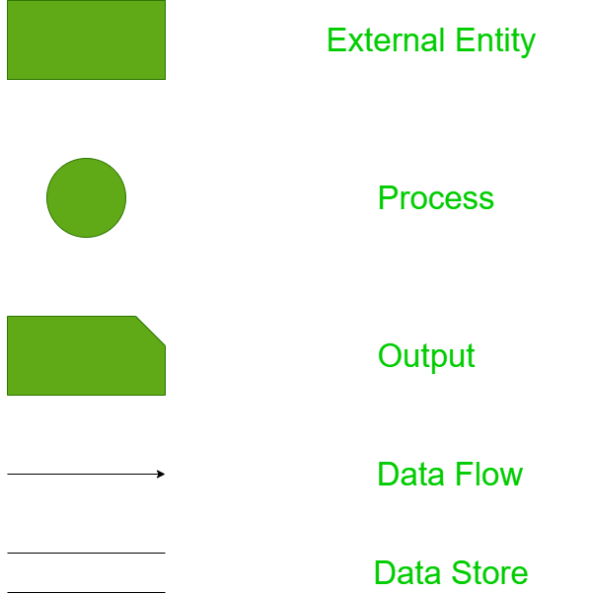

15. CASE Tools – Computer-Aided Software Engineering Tools
All software that supports managerial, technical, or administrative aspects of any part of the software development process is termed as CASE tools.

Use of CASE Tools:
- Facilitating Single Design Methodology: Aiding in the standardization of the development process.
- Rapid Application Development: Improving the speed and quality of system development.
- Testing: Enhancing the testing process through automated checking.
- Documentation: Improving the quality and uniformity of documentation.
- Project Management: Automating various activities involved in project management.
- Productivity and Cost Reduction: Automating various activities in system development and increasing the productivity of the development team.

Role of CASE Tools:
- Project Management
- Data Dictionary
- Code Generation
- User Interface Design
- Schema Generation
- Creation of Metadata for Data Warehouse
- Reverse Engineering
- Re-engineering
- Document Generation
- Version Control
- Object-Oriented Analysis and Design
- Software Testing
- Data Modeling
- Project Scheduling
- Cost Estimation

Advantages of CASE Tools:
- Integrated Development Environment
- Guidance in Development
- Consistency Between the Model and Documentation

Types or Components of CASE Tools:
- Planning and Management Tools
- Analysis Tools
- Design Toolset
- Information Integrator
- Code Generator
- Database Design Toolset
- User Interface Generator
- Report Generator
- Rational Rose: One of the most widely used CASE tools in the software community.
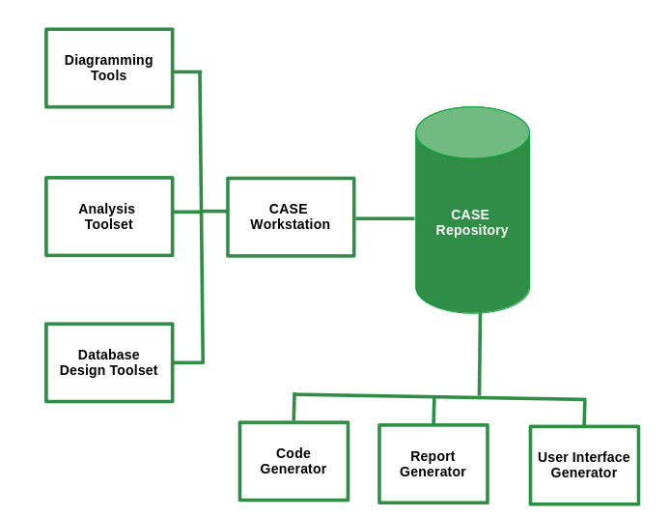
- UML modeling: The Unified Modeling Language is primarily a graphical modeling language used to express designs.
- Emerging CASE tools: Integrated CASE (I-CASE).
- Object-Oriented CASE tools: Paradigm Plus from Protosoft, Rational Rose from Rational, and WithClass

16. Implementation of Systems
It involves coding, testing, creating necessary hardware, and providing training to end-users.

System Testing
A holistic approach to testing the application. Types include Recovery Testing, Security Testing, Stress Testing, Performance Testing, Response Testing, Usability and Documentation Testing.
- Alpha Testing: Carried out by the customer at the developer site in a controlled environment.
- Beta Testing: Carried out at one or more customer sites by end-users.

Converting Old System to the New System:
Can be performed in several ways depending on system criticality and related issues:
- Direct Conversion: Old system is shut down, and the new system starts.
- Pilot Conversion: New system is installed at a single pre-decided location.
- Parallel Conversion: Old system runs alongside the new system until management and users are satisfied.
- Phased Conversion: Different sub-systems of the new system are used in conjunction until the whole new system is converted.

17. Maintenance of Systems
Monitoring, evaluating, and modifying the information system to make necessary desirable changes. Maintenance activity has four key stages:
- Help Desk: Initial stage for users to report issues or seek assistance.
- Analysis: In-depth examination of reported issues and system performance.
- Implementation: Incorporation of enhancements based on analysis findings.
- Release: Deployment of the modified information system to users.

Different Maintenance Activities
- Corrective Maintenance: Rectifying design, coding, and implementation problems detected after system implementation.
- Adaptive Maintenance: Changes in the operation system, hardware, or DBMS.
- Perfective Maintenance: Adding new functionalities and features to the software.
- Preventive Maintenance: Changes made to software to make it easily maintainable and prevent system failure in the future.
Legacy System: A very old and large system modified heavily since its inception. Solutions include replacing software with a package, re-implementing from scratch, discarding software, freezing maintenance and phasing in a new system, or reverse engineering the legacy system.

18. Audit of Computer Systems
An assessment of an information system to provide recommendations and advice to improve system performance and security. It is done by an IS auditor. Objectives of the audit are:
- To improve the quality of the information system.
- Prevent failure.
- Speed up the process.
- Improve cost performance.
- Increase efficiency.
- Reduce risk and enhance system security.
- Standardization.

Responsibility and Authority of the System Auditor:
- Should firmly maintain professional ethics.
- Should be aware of the ethical demands on themselves.
- Should meet internal and external trust by performing an accurate and sincere system audit.
- Must maintain confidentiality of the information provided to them.
- May demand data and material from the division being audited.
- May also demand a report on the implementation of improvements to an audit division as suggested by them.

Factors Audited by IS Auditor:
- Audit of response time: Actual response time compared with the desired response time.
- Audit of broken links: Findings of broken or unavailable links on the website.
- Database Audit: Checking the database integrity and availability.
- Network Audit: Checking the vulnerability and configuration of the network.
- Transaction Audit: Process to find who made changes, what changes were made, and whether the changes were authorized.
- Audit of Computer Security: Reviewing physical and logical security measures.
- Audit of Application: Assessment of manual and programmed internal controls of the information system.

Some Important Terms
- Visual Audit Pro - A software that audits activities like logging on/off, and collects information about software and hardware.
- E-Z Audit -A software that gives information on RAM capacity, network card name, network connect speed, MAC address and TCP/IP information.
- IDEA(Interactive Data Extraction and Analysis) - Used to import information from the database to be audited for further analysis by the auditor.
- Audit Trail - A log of changes made in data, settings and related changes.
Risk Assessment - Evaluating threats and vulnerabilities of IS. two methods are there for analysing the risks:
- Quantitative Risk Analysis - Gives an idea about the amount of risks involved with an event.
- Qualitative Risk Analysis - Gives the degree of risk associated with the institution’s system, networks and information assets.

Disaster Recovery Plan
- Disaster - Earthquakes, floods, fires and terrorist attacks can severely damage an organisation's computing infrastructure.
- Disaster Recovery Plan - A document containing procedures for emergency response, extended backup operations and recovery.

Techniques applied for contingency situations are:
- In-house backup - The process of storing data backups within the organization
- Alternate Storage Area - Store one copy of all AIS files and databases at an alternative site.
- The Disaster Recovery Toolkit - A highly valuable collection of items and documents for ensuring business continuity in disaster.
Contigency Events | Necessary Recovery Action
Loss of Data | Identify the appropriate recovery plan, The location of required recovery files.
Loss of Software | Identify the type of software and location where backup copies are maintained.
Loss of Communication | Identify alternate communication facility, Estimate recovery time.
Loss of hardware | Identify any alternate substitute for the equipment. Estimate replacement cost of hardware.
Loss of Personnel | Identify substitutes for each personnel, if alternates are not available then obtain them from an outside source.
Loss of Facility | Identify all necessary hardware, software, data, and personnel required for normal functioning at the alternative location

Contingency Planning Steps:
- Develop the plan.
- Test the plan.
- Maintain the plan.

19. Viruses
One of the biggest security threats to computer systems can cause irreparable damage to certain systems. Anti-virus measures for protecting against viruses include:
- Make a backup of all data.
- Use anti-virus software.
- Open email attachments with caution.
- Regularly update software.
- Stay updated about the latest security news.

20. Concurrent Audit
Data is audited while the transaction is in progress. It helps in finding missing audit trails and is also used in monitoring largely integrated and automated systems.

Concurrent Audit Techniques
- Integrated Test Facility (ITF) Technique : Auditing software is embedded into the client software.
- The Snapshot Technique: Embedded auditing software takes a snapshot before and after the process of critical processing.
- System Control Audit Review File (SCARF): Embedded auditing software monitors the system transaction uninterruptedly and stores the collected information in a SCARF master file.
- Continuous and Intermittent Simulation techniques (CIS): Used DBMS to trap exceptions.

21. Different Kinds of Information Systems

Management Information System (MIS)
It helps the organization produce information that can aid in improving decision-making, problem-solving, controlling operations, and creating new products or services.Generates semi-structured, ad-hoc reports tailored for strategic management. Examples: Marketing information systems.

Transaction Processing System (TPS)
TPS processes data from business operations, providing essential support for day-to-day operations. Handles routine transactions, employs fixed periodic reporting, and serves operational management needs. Examples: Sales processing systems, and online reservation systems.

Decision Support System (DSS)
DSS utilizes analytical models, specialized databases, and internal data to provide interactive decision support. Offers reports like sensitivity and what-if analyses, catering to individual manager's decision-making needs. Example: Geographic Information System (e.g., IBM's Geo-Manager).

Expert System
Expert Systems apply knowledge from a specific field, delivering expert advice within a defined domain. Provides human-like expert advice; sought by managers seeking specialized knowledge. Example: Medical diagnostic expert systems (e.g., MYCIN).

System Design Interview Questions and Answers [2025]
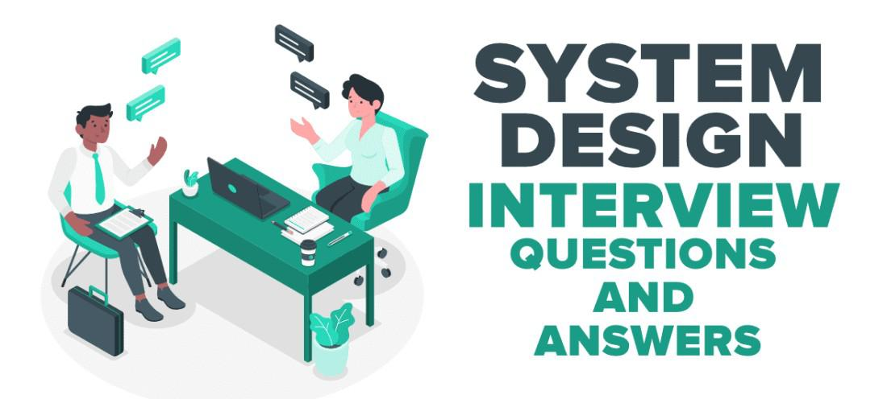

1. Design a URL Shortening Service (TinyURL)
URL shortening service allows users to enter a long URL, and then it returns a shorter, unique URL. These services generate a short URL if the user gives a long URL and if the user gives a short URL then it returns the original long URL.

Things to discuss and analyze:
- Given a long URL, the service should generate a shorter and unique alias for it.
- When the user hits a short link, the service should redirect to the original link.
- Consider scalability if 1000's URL shortening requests come every second.
- Service handle redirects.
- Support for custom short URLs.
- Track click stats.
- Delete expired URLs.
- The system should be highly available.
You need to consider three things while designing this service.
- API(REST API) - Discuss how the client will follow an approach to communicate with the service along with the load balancer which is the front end of the service.
- Application Layer - Discuss how the worker thread or hosts that will take the long URL, generate the tiny URL and how it will store both of the URLs in the database.
- Persistence Layer - Database

2. Design YouTube/Netflix (A Global Live Video Streaming Service)
Design a video streaming service like Youtube/Netflix where users can upload/view/search videos. The service should be scalable where a large number of users can watch and share the videos simultaneously. It will be storing and transmitting petabytes and petabytes of data.

Things to discuss and analyze:
- Approach to record stats about videos e.g. the total number of views, up-votes/down-votes, etc.
- Adding comments on videos in real-time.

3. Design Facebook Messenger or WhatsApp (A Global Chat Service)
To design a global chat service like Facebook Messenger or WhatsApp, you need to focus on real-time communication, scalability, and reliability. Start with user management for registration and login, then implement messaging using technologies like WebSockets for real-time data transfer. For message storage, use distributed databases to handle large amounts of data across different regions. Ensure reliability with features like delivery receipts and read acknowledgments.

Things to discuss and analyze:
- Approach for one-on-one text messaging between users.
- Approach for extending the design to support group chats.
- Delivered and read status
- What action needs to be taken if the user is not connected to the internet?
- Push notifications
- Sending media like images or other documents
- Approach for providing end-to-end message encryption.

4. Design Quora/Reddit/HackerNews (A Social Network + Message Board Service)
These services allow users to post questions, share links and answer the questions of other users. Users can also comment on questions or shared links.

Things to discuss and analyze:
- Approach to record stats of each answer such as the number of views, up-votes/down-votes, etc.
- Follow options should be there for users to follow other users or topics.
- News feed generation which means users can see the list of top questions from all the users and topics they follow on their timeline.

5. Design Search Typeahead (Autocomplete)
Typeahead service allows users to type some query and based on that it suggests top searched items starting with whatever the user has typed.

Things to discuss and analyze:
- Approach to storing previous search queries
- Real-time requirement of the system
- Approach to keep the data fresh.
- Approach to find the best matches to the already typed string
- Queries per second are to be handled by the system.
- Criteria for choosing the suggestions.
- A total number of data to be stored.
- Approach to find the best matches to the already typed string

6. Design Dropbox/Google Drive/Google Photos (A Global File Storage and Sharing Service)
Design a file or image hosting service that allows users to upload, store, share, delete, and download files or images on their servers and provides synchronization across various devices.

Things to discuss and analyze:
- Approach to upload/view/search/share/download files or photos from any device.
- Service should support automatic synchronization between devices, i.e., after updating a file on one device, it should get synchronized on all devices.
- ACID (Atomicity, Consistency, Isolation, and Durability) properties should be present in the system.
- Approach to track permission for file sharing.
- Allowing multiple users to edit the same document.
- The system should support storing large files up to a GB.

7. Design a Web Crawler
Design a Web Crawler scalable service that collects information (crawls) from the entire web and fetches hundreds of millions of web documents.

Things to discuss and analyze:
- Approach to finding new web pages.
- Approach to prioritize web pages that change dynamically.
- Ensure that the crawler is not unbounded on the same domain.

8. Design Facebook, Twitter, or Instagram.
You need to design a social media service for billions of users. Most of the interviewers spend time discussing news feed generation services in these apps.

Features to be considered:
- Some of the specific Twitter/Facebook/Instagram features are to be supported.
- Privacy controls around each tweet or post.
- Users should be able to post tweets also the system should support replies to tweets/grouping tweets by conversations.
- Users should be able to see trending tweets/posts.
- Direct messaging
- Mentions/Tagging.
- The user should be able to follow another user.

Things to analyze:
- The system should be able to handle the huge amount of traffic for billions of users.
- Number of followers
- The number of times the tweet has been favored.

9. Design Uber or Lyft (A Ride-Sharing Service)
Design a service where a user requests a ride from the app, and a driver arrives to take them to their destination. A frequently asked interview question in the system design round of interviews.

Things to analyze and discuss:
- The backend is primarily serving mobile phone traffic. uber app talks to the backend over mobile data.
- How dispatch system works (GPS/ location data is what drives the dispatch system)? How efficiently can the user match request with nearby drivers?
- How do maps and routing work in Uber? How ETAs are calculated?
- An efficient approach to store millions of geographical locations for drivers/riders who are always on the move.
- Approach to handle millions of updates to driver location.
- Dispatch is mostly built using Node.js
- Services: Business logic services are mostly written in Python.
- Databases: Postgres, Redis, MySQL.

10. Design an API Rate Limiter(Github)
Design a service or tool that monitors the number of requests per window of time a service agrees to allow. If the number of requests exceeds the rate limit blocks all the excess calls.

Things to analyze and discuss:
- Limiting the number of requests an entity can send to an API within a time window, for example, twenty requests per second.
- Rate limiting should work for a distributed setup, as the APIs are available through a group of servers.
- How to handle throttling (soft and hard throttling etc.).

11. Design a Notification System (Push Notifications)
Design a Notification System that monitors the number of requests a service receives and blocking excess calls when the limit is exceeded.

Things to analyze and discuss:
- Facilitate real-time user engagement through timely notifications.
- Implement user registration with customizable preferences.
- Define events triggering notifications from external systems.
- Generate dynamic and personalized notification content.
- Integrate with push notification services for cross-platform delivery.
- Optimize delivery through batch processing and user feedback.
- Prioritize secure communication and token management for data protection.
- Implement throttling mechanisms to control notification volume.
- Ensure scalability with horizontal scaling and redundancy.
- Utilize logging and auditing for monitoring, troubleshooting, and performance optimization.

Conclusion
In conclusion, mastering system design interviews requires understanding key principles like scalability, performance, reliability, data management, and security. Practice with common questions on distributed systems, load balancers, databases, caching, and microservices is crucial. Familiarity with trade-offs and best practices, combined with regular practice and feedback, will enhance your performance and confidence in these interviews.

System Analysis Design -Chapter 3 - Information Gathering

Learning Goals
 Strategy to gather information for computerization.
 Various sources of information.
 Methods of searching for information.
 Interviewing techniques to gather information from line managers to top management.
 Methods of consensus for formulating requirements.

Information Gathering Strategies
 Identify Information Sources.
 Evolve a method of obtaining information from the identified sources.
 Use Information flow model of organization.

Information Sources
 Users of System.
 Forms and Documents used in the organization.
 Procedure manuals, rule books etc.
 Reports used by the organization
 Existing computer programs(If Any).
 Interviews are very important.
 Use organization chart.
 Understand the importance of the people who operate the system-Clerks,Line managers.
 Gather information from Middle level persons who have lot of experience
 Gather both qualitative and quantitative information & Observe how the organization works.

Information Gathering Tools
 Review of Literature, Procedures and Forms.
 On Site Observation.
 Interviews and Questionnaires.

Review of Literature, Procedures and Forms
 Who uses the forms?
 How important are they to the user?
 Do the forms include all the necessary information?
 What items should be added or deleted?
 How many departments receive the existing forms? Why?
 How readable and easy to follow in the form?
 How does the information in the form help other users make better decisions?

On Site Observation
 What kind of system is it? What does it do?
 Who runs the system? Who are the important people in it?
 What is the history of the system? How did it get to its present stage of development?
 What kind of system is it in comparison with other systems in the organization?
 Is it a fast paced or slow system to external crises?

Problems in On Site Observation
 Intruding into the user’s area often results in adverse reactions by the staff, therefore adequate preparation and training are important.
 Attitudes and motivations cannot be readily observed.
 Observations are subject to error due to the observer’s misinterpretation.
 Unproductive, long hours are often spent in an attempt to observe specific one time activities or events.

Interviews
 It is a face to face interpersonal role situation, in which a person called the interviewer, asks questions to another person, designed to gather information about a problem.
 Advantages of Interview:
 It is a superior technique used for exploring areas.
 It offers better opportunity to evaluate the validity of the information gathered.
 The interviewer can observe not only what they say and how they say.
 It is an effective technique for eliciting information about complex subjects.
 Many people enjoy being interviewed, regardless of the subject. Interviews
 Drawbacks of Interview:
 long preparation time

Planning an Interview
 Make a list of people to be interviewed and in what order
 Plan and note down a list of questions to be asked
 Plan several interviews with same person mainly to clarify doubts
 Interview groups as appropriate

Interviewing Technique
 Make appointment.
 Assign time.
 Read background material.
 State purpose of interview.
 Be punctual and pay attention to what user says.
 Obtain both quantitative and qualitative Information
 Discriminate between essential and appropriate requirements
 State what you understand and get it confirmed
 Do not extend interview
 Summarize information gathered and get it checked by the interviewee

Use of Questionnaires
 Questionnaires useful for statistical data collection
 Useful when large number of persons have to respond
 Make questionnaires short
 Design questionnaires by enumerating objectives and data needed to meet the objectives
 Several follow-ups/personal interviews may be required to get questionnaires back from respondents

Advantages of Questionnaires
 It is economical and requires less skills to administer than the interview.
 A questionnaire can be administered to large number of individuals simultaneously
 Questionnaires ensure uniformity of questions
 In a questionnaire respondents give opinion without fear
 Respondents have time to think the questions over and do calculations to provide more accurate data

Types of Interviews and Questionnaires
 The Unstructured Alternative
 The Structured Alternative

The Unstructured Alternative
 It is a relatively nondirective information gathering technique.
 It allows respondents to answer questions freely in their own words.
 The responses are spontaneous rather than forced.
 System analyst should encourage the respondent to talk freely

The Structured Alternative
 The questions are presented with exactly the same wording and in the same order
 Questions may be either closed or open ended.
 An open ended question requires no response direction or specific response

Closed Questions
 Closed questions are those in which the responses are presented as a set of alternatives.
There are five major varieties:
▪ Fill in the blanks:
▪ Dichotomous (yes/no type) questions:
▪ Ranking scales questions
▪ Multiple choice questions
▪ Rating scales questions

Information Gathering other Methods
 Existing system(If any)
 Systems in similar organization
 Observe workflow in workplace
 Case repository in own organization

20 System Analysis and Design Interview Questions and Answers – CLIMB

1. What is System Analysis and Design?
System analysis and design is the process of planning, creating, testing, and maintaining software systems. This can include anything from small programs to large, complex systems. The goal of system analysis and design is to improve the efficiency and effectiveness of a system.

2. What are the different phases in a typical system development life cycle?
The different phases in a typical system development life cycle are:
1. Planning and feasibility study
2. System analysis
3. System design
4. Implementation and testing
5. Deployment and maintenance

3. Can you explain what information systems architecture is?
Information systems architecture is the high-level design of an information system. It provides a blueprint for how the system will be structured and organized. The architecture defines the system’s components and how they will work together. It also establishes standards and guidelines for development and implementation.

4. How can data flow diagrams be used to model business processes?
Data flow diagrams can be used to model business processes by showing the flow of data through the system. This can be helpful in understanding how the system works and identifying potential bottlenecks.

5. What do you understand by a use case diagram? How can it help with system analysis?
A use case diagram is a type of behavioral diagram that shows how a system should interact with users in order to achieve a specific goal. In other words, it is a graphical representation of the steps that need to be taken in order to complete a task. Use case diagrams can be very helpful in system analysis because they can provide a clear and concise overview of the functionality that a system needs to provide.

6. What is the difference between an activity, sequence, and state diagram?
An activity diagram is used to model the flow of activities within a system. A sequence diagram is used to model the sequence of messages exchanged between objects within a system. A state diagram is used to model the different states that an object can be in.

7. Can you explain what a class diagram is and how it relates to object-oriented programming languages like Java and C++?
A class diagram is a type of modeling diagram that is used to represent the structure of a system by showing the relationships between classes of objects. In object-oriented programming languages like Java and C++, a class is a template for creating objects, and each object is an instance of a class. The class diagram can be used to show the relationships between different classes of objects, as well as the relationships between the objects themselves.

8. What’s your understanding of functional requirement specification documents?
A functional requirement specification document outlines the specific functions that a system, software, or other product must be able to perform. This can include things like input/output requirements, performance requirements, data storage requirements, etc. This document is important in helping to ensure that the final product meets the needs of the customer or client.

9. What is the purpose of a context diagram?
A context diagram is a high-level view of a system that shows the system’s boundaries and the major components that interact with it. Context diagrams are useful for understanding the big picture of a system and for identifying the major stakeholders and their interests.

10. What is the significance of a Gantt chart?
Gantt charts are a popular project management tool that can be used to track the progress of a project by displaying the tasks involved as bars on a timeline. This allows project managers to see at a glance which tasks are behind schedule and which are on track, and to make adjustments to the project plan as needed.

11. What is database design? Why is it important for a software analyst to know about it?
Database design is the process of creating a detailed data model of a database. This data model includes all the data elements and their relationships. Database design is important for a software analyst to know about because it is necessary for understanding how data is stored and accessed in a database. A software analyst needs to be able to understand the data model in order to be able to effectively design software that interacts with the database.

12. What factors should be considered when designing a database schema?
There are a few key factors to consider when designing a database schema:
1. The first is to identify the entities that will be stored in the database, and the relationships between them.
2. The second is to decide on the structure of the database, including the data types that will be used for each field.
3. The third is to choose an appropriate indexing strategy to ensure efficient retrieval of data.

13. How would you deal with legacy code that needs to be refactored or rewritten?
There are a few different ways to deal with legacy code that needs to be refactored or rewritten. One option is to create a new version of the code from scratch, which can be time-consuming but may be necessary if the legacy code is very old or difficult to work with. Another option is to refactor the code piece by piece, which can be less disruptive but may take longer in the long run. Finally, you could also try to rewrite the code using a different programming language or framework, which can be a good way to improve its maintainability and extensibility.

14. What is the best way to reduce complexity when analyzing a large code base?
One way to reduce complexity when analyzing a large code base is to use a tool like JArchitect. This tool can help you to visualize the code base and identify areas of complexity. Another way to reduce complexity is to use a tool like SonarQube, which can help you to identify issues with the code and provide recommendations for how to fix them.

15. What tools do you use to analyze source code?
I use a variety of tools to analyze source code, depending on the language it is written in and the purpose of the analysis. For example, if I am looking for potential security vulnerabilities, I might use a tool like Fortify SCA. If I am trying to understand how a system works, I might use a tool like reverse engineering to decompile the code and generate UML diagrams.

16. What is the importance of using agile methodologies while performing software analysis tasks?
Agile methodologies are important for software analysis tasks because they emphasize the need for constant communication and collaboration between the development team and the client. This is important in order to ensure that the final product meets the client’s needs and expectations. Additionally, agile methodologies place an emphasis on delivering working software early and often, which is also important in order to ensure that the client is happy with the final product.

17. What is the difference between functional and non-functional requirements? Give some examples of each type of requirement.
Functional requirements are those that describe what a system is supposed to do, while non-functional requirements are those that describe how a system is supposed to do it. For example, a functional requirement might be that a system be able to search for and retrieve information from a database, while a non-functional requirement might be that the system be able to do so quickly and efficiently. Other examples of non-functional requirements include requirements for security, scalability, and usability.

18. Is there any difference between SDLC and SADLC? If yes, then what is it?
The main difference between SDLC and SADLC is that SDLC is more focused on the technical aspects of designing and developing a system, while SADLC is more focused on the business aspects. SADLC also puts more emphasis on user involvement and on understanding the user’s needs before starting to design the system.

19. What is the most common mistake made by junior software analysts? Do you think its something that can be avoided?
The most common mistake made by junior software analysts is failing to understand the user’s needs. This can be avoided by taking the time to interview the user and understand their workflows and needs.

20. In your opinion, what is the most difficult part of the system analysis process?
I believe that the most difficult part of the system analysis process is understanding the needs of the user. In order to create an effective system, it is essential to have a clear understanding of what the user is looking for and what their specific needs are. This can be difficult to obtain, as sometimes users themselves are not entirely sure of what they need or want. It is the job of the analyst to try to understand the user’s needs and requirements and to translate them into a system that will meet those needs.

5 Information Systems Analyst Interview Questions and Answers

1.1. Describe a situation where you had to analyze a large dataset to derive actionable insights.

Introduction
This question assesses your analytical skills and ability to turn data into business value, which is crucial for an Information Systems Analyst.

How to answer
- Start with a brief description of the dataset and its relevance to the business.
- Explain the tools and methods you used for analysis (e.g., Excel, SQL, Python).
- Discuss the specific insights you discovered and their implications.
- Highlight how you communicated these insights to stakeholders.
- Conclude with the impact of your analysis on decision-making.

What not to say
- Focusing solely on technical details without discussing the business context.
- Failing to mention the tools or techniques used.
- Not explaining how the insights were communicated or implemented.
- Overlooking the importance of collaboration with other teams.

Example answer
“At my internship with a local retail company, I analyzed customer purchase data using Excel and SQL to identify buying trends. I discovered that sales spiked during specific promotions, which I presented to the marketing team. This insight led to a targeted marketing campaign that increased sales by 20%. This experience reinforced my belief in data-driven decision-making.”

1.2. How do you prioritize tasks when working on multiple projects simultaneously?

Introduction
This question examines your time management and prioritization skills, essential for handling various responsibilities as a Junior Information Systems Analyst.

How to answer
- Describe your method for assessing the urgency and importance of tasks.
- Explain how you communicate with stakeholders to align priorities.
- Discuss any tools or techniques you use for task management (e.g., Trello, Asana).
- Provide an example from your experience where prioritization led to successful project outcomes.
- Emphasize the importance of flexibility in adjusting priorities.

What not to say
- Claiming you handle everything at once without a system.
- Neglecting to mention communication with team members about priorities.
- Overemphasizing personal productivity over team goals.
- Suggesting that prioritization is not important.

Example answer
“In my previous role during an internship at Siemens, I often juggled multiple projects. I used a priority matrix to evaluate urgency versus importance, which helped me focus on critical tasks first. For instance, I prioritized a data modeling project that was due for a presentation, ensuring I communicated my plan with my team. This approach improved our overall efficiency and project delivery time.”

2.1. Can you describe a time when you successfully implemented a new information system in an organization?

Introduction
This question assesses your experience with system implementation, your technical skills, and your ability to work with stakeholders, which are critical for an Information Systems Analyst.

How to answer
- Use the STAR method (Situation, Task, Action, Result) to structure your response
- Clearly define the specific system you implemented and its purpose
- Explain your role in the implementation process and the steps you took
- Discuss how you collaborated with different departments or stakeholders
- Quantify the success of the implementation with metrics or feedback

What not to say
- Vaguely describing the system without technical specifics
- Failing to mention your personal contributions
- Not addressing challenges faced during implementation
- Overlooking the impact on end-users or stakeholders

Example answer
“At a financial services firm in São Paulo, I led the implementation of a new customer relationship management system. I coordinated with the sales and IT teams to map out requirements, and we conducted user training to ensure a smooth transition. As a result, we improved customer response times by 30% and increased user satisfaction scores by 25%. This experience taught me the importance of stakeholder engagement and thorough training.”

2.2. How do you approach gathering requirements from stakeholders for a new system?

Introduction
This question evaluates your analytical and communication skills, as well as your ability to understand and translate stakeholder needs into functional specifications.

How to answer
- Describe your methodology for requirements gathering, such as interviews, surveys, or workshops
- Explain how you ensure that all relevant stakeholders are included in the process
- Discuss how you prioritize requirements based on business needs
- Mention tools or techniques you use to document and validate requirements
- Share an example of a successful requirements gathering process

What not to say
- Ignoring the importance of stakeholder involvement
- Providing a vague or unclear process
- Failing to mention any tools or documentation methods
- Not emphasizing the need for follow-up and validation

Example answer
“I typically use a combination of interviews and workshops to gather requirements. In my last project at a healthcare company, I facilitated a workshop with key stakeholders, which ensured we captured a wide range of needs. I documented these requirements in a detailed specification document, which we validated through follow-up interviews. This collaborative approach helped us prioritize features that aligned with strategic goals, resulting in a user-friendly system that met our needs.”

3.1. Can you describe a complex information system project you managed and how you ensured its success?

Introduction
This question is critical as it evaluates your project management skills, technical expertise, and ability to deliver results in complex scenarios, which are essential for a Senior Information Systems Analyst.

How to answer
- Use the STAR method to structure your response: Situation, Task, Action, Result.
- Clearly define the project's scope and objectives.
- Detail the specific roles and responsibilities you had in managing the project.
- Explain the methodologies you used (e.g., Agile, Waterfall) and why they were appropriate.
- Quantify the project's success with metrics such as time saved, costs reduced, or user satisfaction.

What not to say
- Failing to provide concrete examples or metrics of success.
- Overemphasizing technical jargon without explaining concepts.
- Neglecting to mention team collaboration and stakeholder communication.
- Focusing solely on challenges without discussing solutions and outcomes.

Example answer
“At British Telecom, I managed a project to implement a new customer relationship management system. The initial phase faced resistance due to user concerns, so I organized workshops to gather feedback and adjust our approach. By adopting Agile methodologies, we improved user engagement and completed the project two weeks ahead of schedule, leading to a 30% increase in customer satisfaction scores.”

3.2. How do you approach data security and compliance in information systems?

Introduction
This question assesses your understanding of data security and compliance, which are critical responsibilities for an Information Systems Analyst, especially in the UK with GDPR regulations.

How to answer
- Discuss your knowledge of data protection regulations relevant to the UK, such as GDPR.
- Describe your experience in implementing security measures within information systems.
- Provide examples of how you conduct risk assessments and audits.
- Explain how you educate team members on compliance best practices.
- Mention any tools or frameworks you utilize for compliance monitoring.

What not to say
- Giving vague answers without specific examples or regulations.
- Underestimating the importance of compliance and data protection.
- Failing to mention collaboration with legal or security teams.
- Neglecting to discuss continuous improvement in security practices.

Example answer
“In my role at Vodafone, I implemented a comprehensive data security strategy that aligned with GDPR requirements. I conducted regular risk assessments and collaborated with the legal team to ensure compliance. Additionally, I led training sessions for staff on data protection best practices, which resulted in a 40% reduction in compliance-related incidents over a year.”

3.3. Describe a time when you had to adapt to a significant change in technology or process within your organization.

Introduction
This question evaluates your adaptability and willingness to embrace change, which is essential in the fast-evolving field of information systems.

How to answer
- Use the STAR method to provide a structured response.
- Clearly outline the change and the reasons behind it.
- Discuss your initial reactions and how you approached the change.
- Detail the steps you took to adapt, including any training or learning you pursued.
- Highlight the positive outcomes of your adaptability for the team or organization.

What not to say
- Focusing solely on the difficulties you faced without discussing solutions.
- Expressing a negative attitude toward change.
- Failing to mention how you supported others in adapting.
- Neglecting to highlight the benefits that came from the change.

Example answer
“When my previous employer, Capita, transitioned to a cloud-based information system, I initially found it challenging. However, I embraced the change by enrolling in training sessions and leading knowledge-sharing meetings. My proactive approach not only helped me become proficient quickly but also supported my colleagues in the transition, resulting in a smoother implementation and improved system performance.”

4.1. Can you describe a project where you implemented a new information system that significantly improved operations?

Introduction
This question assesses your experience in system implementation and your ability to drive operational improvements, which are essential components of the Lead Information Systems Analyst role.

How to answer
- Use the STAR method to structure your response: Situation, Task, Action, Result.
- Clearly describe the operational challenges that led to the need for a new system.
- Detail your role in researching, selecting, and implementing the system.
- Explain how you engaged stakeholders and trained users.
- Quantify the improvements in efficiency, productivity, or cost savings.

What not to say
- Failing to mention specific metrics or outcomes from the project.
- Focusing too much on technical details without discussing the business impact.
- Not acknowledging team contributions or collaboration.
- Overlooking the importance of user training and adoption.

Example answer
“At a telecommunications company in Mexico, I led a project to implement a new customer relationship management system. Our previous system was outdated and resulted in slow response times. I conducted stakeholder interviews to identify requirements and selected a cloud-based solution that integrated with our existing tools. After a successful rollout, we saw a 30% reduction in customer response times and a 20% increase in customer satisfaction scores. This experience highlighted the importance of user engagement and training for successful system adoption.”

4.2. How do you ensure data integrity and security in the information systems you manage?

Introduction
This question evaluates your understanding of data governance, security measures, and your ability to protect sensitive information, which is crucial for the Lead Information Systems Analyst role.

How to answer
- Discuss your knowledge of data integrity standards and practices.
- Explain your experience with security protocols and compliance regulations.
- Describe how you conduct regular audits and assessments of data systems.
- Detail your approach to training staff on data security best practices.
- Mention any specific tools or technologies you utilize to enhance data security.

What not to say
- Suggesting that data security is solely the IT department's responsibility.
- Failing to mention specific practices or protocols you follow.
- Overlooking the importance of user education on security measures.
- Neglecting to discuss compliance with relevant regulations.

Example answer
“In my previous role at a financial services firm, I implemented a comprehensive data governance framework that included regular audits, user access controls, and encryption for sensitive data. I trained all staff on security best practices and established a protocol for reporting any anomalies. As a result, we maintained 100% compliance with data protection regulations and significantly reduced the risk of breaches. I believe that a culture of security awareness is key to safeguarding our data assets.”

5.1. Can you describe a time when you implemented a new information system that significantly improved operational efficiency?

Introduction
This question is crucial for evaluating your ability to manage and implement technology solutions that drive operational improvements, which is a key responsibility for an Information Systems Manager.

How to answer
- Provide a clear context of the operational challenges faced before the implementation
- Detail the specific system you chose and why it was selected
- Explain the implementation process, including team involvement and any challenges faced
- Quantify the improvements in efficiency or productivity post-implementation
- Share any feedback received from stakeholders or users

What not to say
- Focusing too much on technical jargon without explaining the business impact
- Neglecting to mention the role of your team and collaboration
- Failing to provide quantifiable results or metrics
- Not discussing any challenges or how they were overcome

Example answer
“At a previous role with Bank of America, I led the implementation of a new customer relationship management system that streamlined our communication processes. Initially, we faced resistance from staff, but after conducting training sessions and incorporating feedback, we saw a 30% increase in customer response times and a 25% increase in customer satisfaction ratings within six months. This taught me the importance of user buy-in during technology transitions.”

5.2. How do you ensure the security and compliance of information systems within your organization?

Introduction
This question assesses your understanding of cybersecurity and compliance, which are critical to protecting sensitive data and maintaining regulatory standards.

How to answer
- Discuss your knowledge of relevant regulations (e.g., GDPR, HIPAA) and industry standards
- Explain the strategies you employ to assess risk and implement security measures
- Describe the importance of staff training and awareness programs
- Provide examples of audits or assessments you've conducted
- Mention any tools or technologies you use to monitor compliance and security

What not to say
- Underestimating the importance of compliance or security measures
- Providing vague or generic answers without specific examples
- Failing to mention collaboration with IT security teams
- Neglecting to discuss ongoing monitoring and improvement processes

Example answer
“In my role at Deloitte, I ensured compliance with GDPR by conducting regular risk assessments and implementing a data encryption strategy across our information systems. I also developed a comprehensive training program for all employees to raise awareness about data protection. After one audit, we achieved a 98% compliance rate, demonstrating the effectiveness of our measures and the importance of continuous education and training.”

System Design Interview Questions

System Design Interview Questions for Freshers

1. What is CAP theorem?
CAP(Consistency-Availability-Partition Tolerance) theorem says that a distributed system cannot guarantee C, A and P simultaneously. It can at max provide any 2 of the 3 guarantees. Let us understand this with the help of a distributed database system.
- Consistency: This states that the data has to remain consistent after the execution of an operation in the database. For example, post database updation, all queries should retrieve the same result.
- Availability: The databases cannot have downtime and should be available and responsive always.
- Partition Tolerance: The database system should be functioning despite the communication becoming unstable.
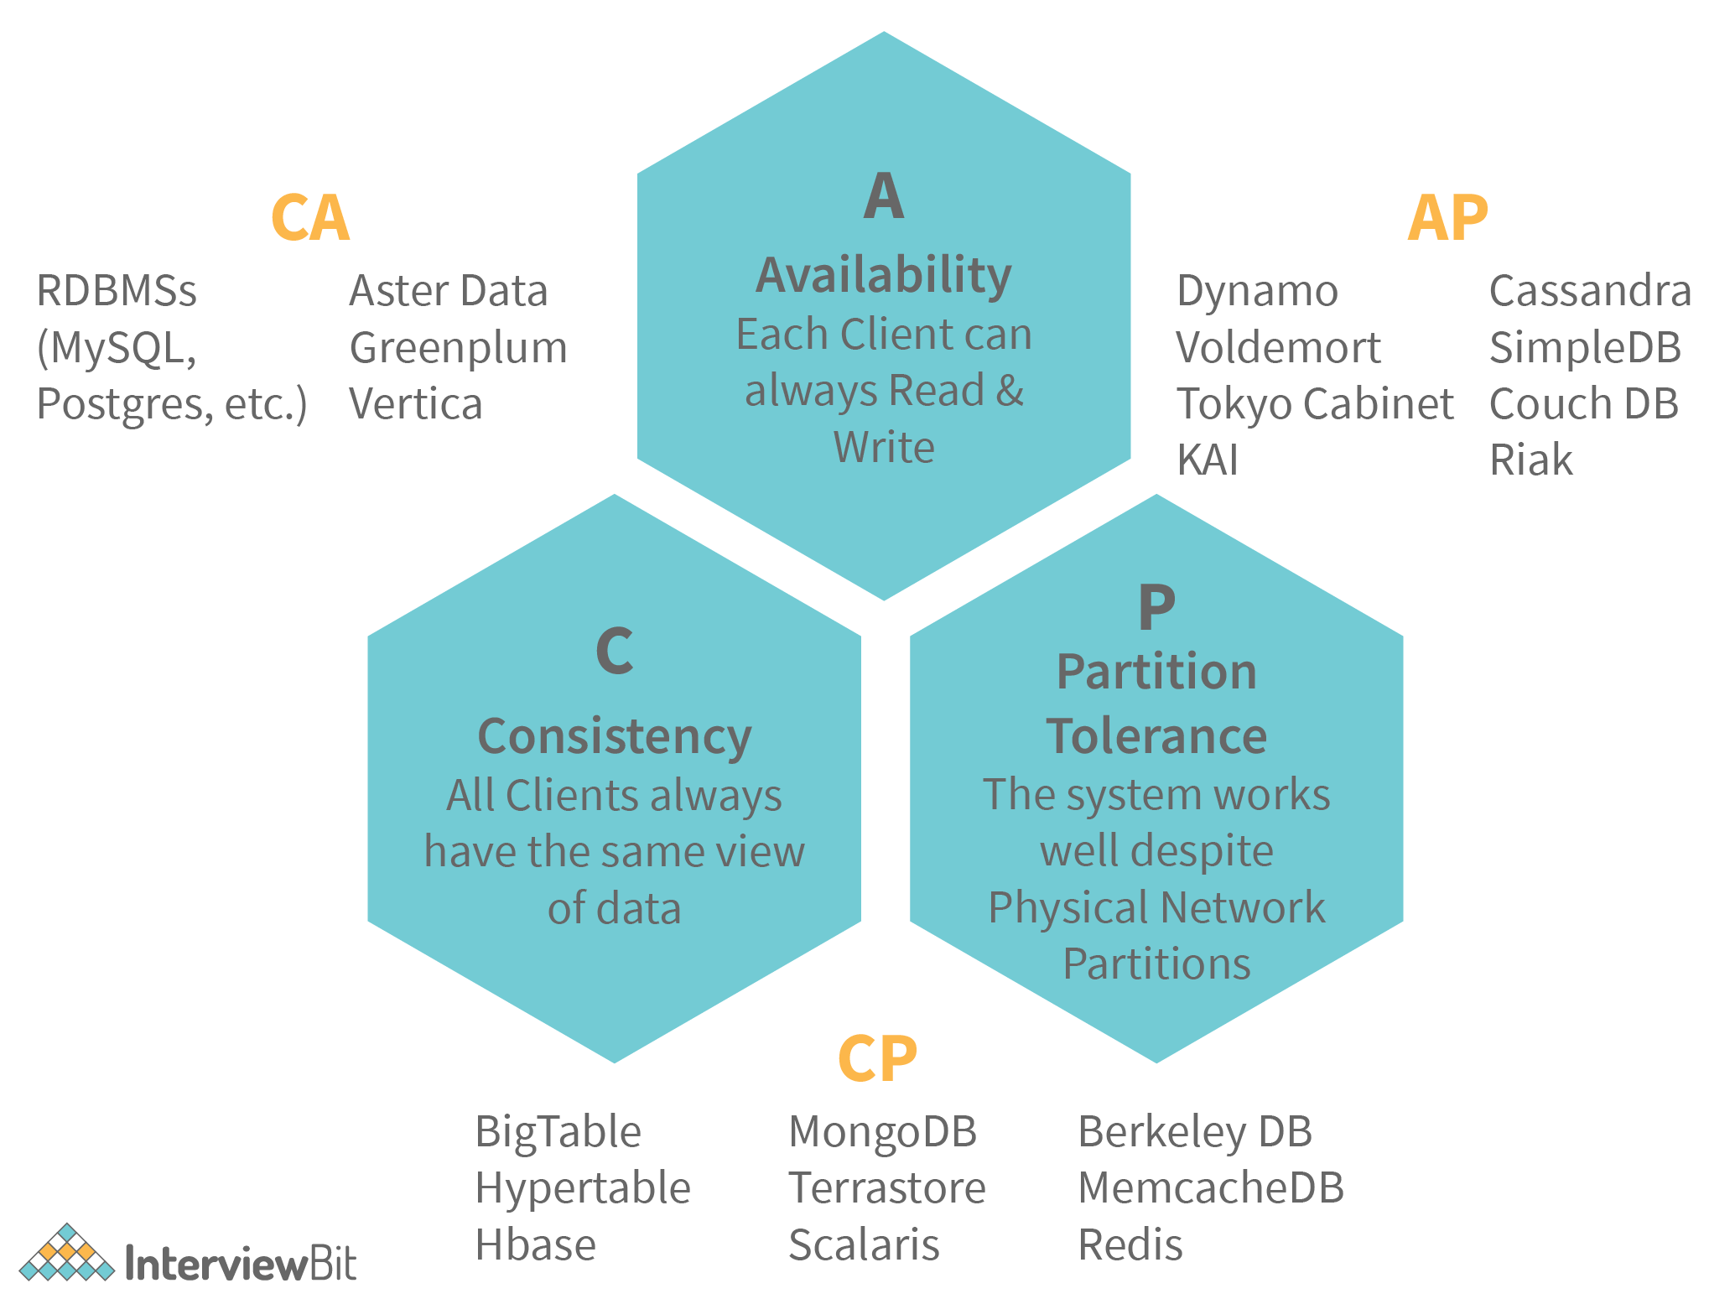
The following image represents what databases guarantee what aspects of the CAP Theorem simultaneously. We see that RDBMS databases guarantee consistency and Availability simultaneously. Redis, MongoDB, Hbase databases guarantee Consistency and Partition Tolerance. Cassandra, CouchDB guarantees Availability and Partition Tolerance.

2. How is Horizontal scaling different from Vertical scaling?
- Horizontal scaling refers to the addition of more computing machines to the network that shares the processing and memory workload across a distributed network of devices. In simple words, more instances of servers are added to the existing pool and the traffic load is distributed across these devices in an efficient manner.
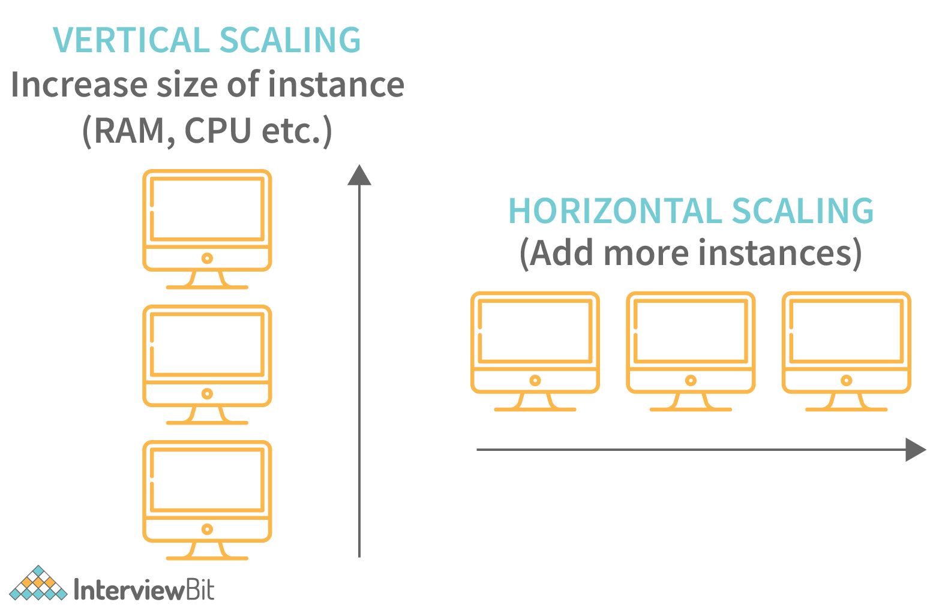
- Vertical scaling refers to the concept of upgrading the resource capacity such as increasing RAM, adding efficient processors etc of a single machine or switching to a new machine with more capacity. The capability of the server can be enhanced without the need for code manipulation.
Horizontal scaling vs. Vertical scaling:
Category | Horizontal Scaling | Vertical Scaling
Load Balancing | Requires load balancing for distributing request traffic across multiple machines. | Since there is just one single machine, the load balancer is not required.
Failure Resilience | This is more resistant to application failure because if one server fails, traffic is routed to other servers. | This is more prone to failure as there is only one machine and failure of this results in failure of the entire application.
Machine Communication | Since there are multiple machines being involved, it is very much necessary to have network communication. | Vertical scaling makes use of inter-process communication within the machine which makes it quite fast.
Data Consistency | There exist possibilities of data inconsistencies here because there are different machines for handling different requests which might result in data being out of sync. | As there is only one machine, there is no issue of data inconsistency.
Limitations | Since this scaling requires multiple servers, there might be concerns on budget and space but the scaling of the application can be done as much as needed based on the business needs. | Vertical scaling has a limit on the capacity of the resources that are achievable. If the resources are scaled up above this limit, then the application might crash and result in downtime.

3. What do you understand by load balancing? Why is it important in system design?
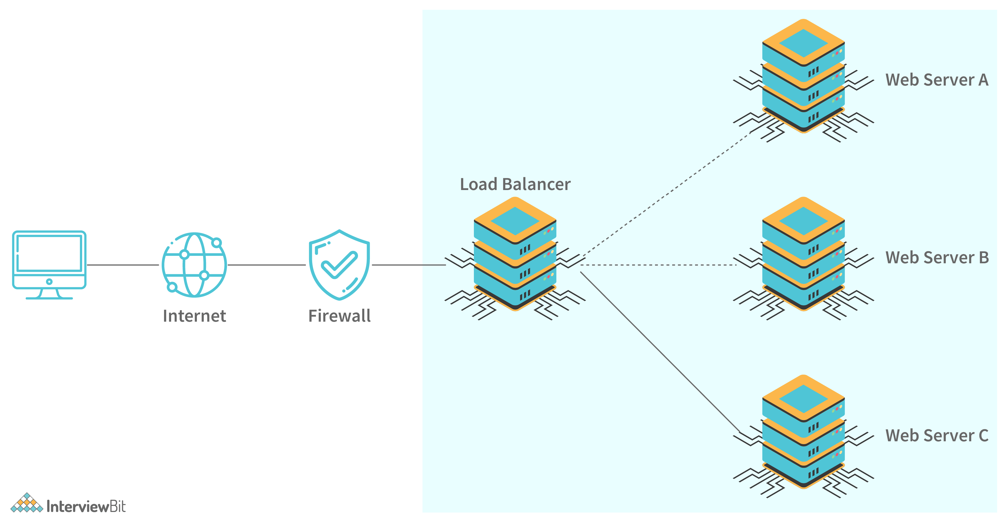
Load balancing refers to the concept of distributing incoming traffic efficiently across a group of various backend servers. These servers are called server pools. Modern-day websites are designed to serve millions of requests from clients and return the responses in a fast and reliable manner. In order to serve these requests, the addition of more servers is required. In such a scenario, it is essential to distribute request traffic efficiently across each server so that they do not face undue loads. Load balancer acts as a traffic police cop facing the requests and routes them across the available servers in a way that not a single server is overwhelmed which could possibly degrade the application performance. When a server goes down, the load balancer redirects traffic to the remaining available servers. When a new server gets added to the configuration, the requests are automatically redirected to it. Following are the benefits of load balancers:
- They help to prevent requests from going to unhealthy or unavailable servers.
- Helps to prevent resources overloading.
- Helps to eliminate a single point of failure since the requests are routed to available servers whenever a server goes down.
- Requests sent to the servers are encrypted and the responses are decrypted. It aids in SSL termination and removes the need to install X.509 certificates on every server.
- Load balancing impacts system security and allows continuous software updates for accomodating changes in the system.

4. What do you understand by Latency, throughput, and availability of a system?
Performance is an important factor in system design as it helps in making our services fast and reliable. Following are the three key metrics for measuring the performance:
- Latency: This is the time taken in milliseconds for delivering a single message.
- Throughput: This is the amount of data successfully transmitted through a system in a given amount of time. It is measured in bits per second.
- Availability: This determines the amount of time a system is available to respond to requests. It is calculated: System Uptime / (System Uptime+Downtime).

5. What is Sharding?
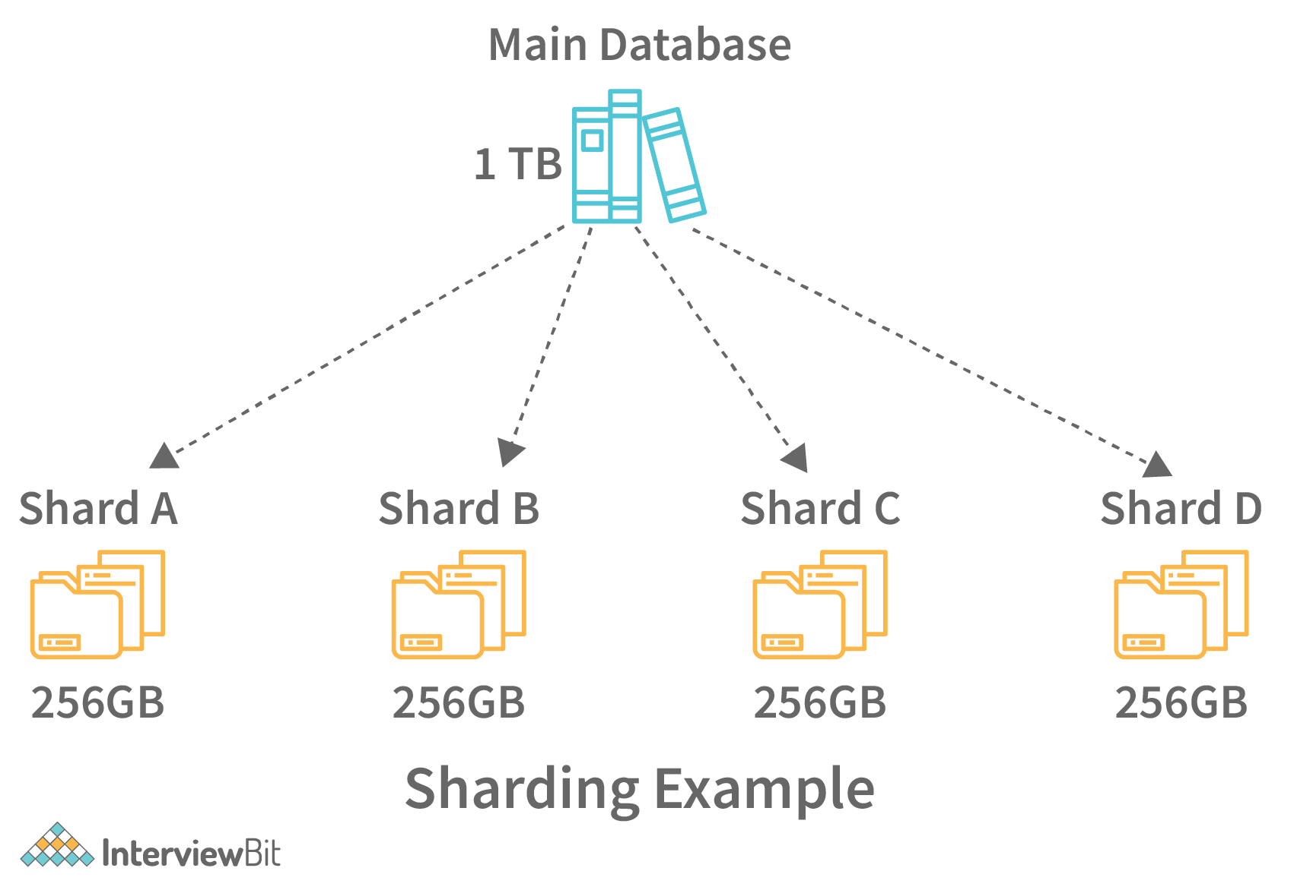
Sharding is a process of splitting the large logical dataset into multiple databases. It also refers to horizontal partitioning of data as it will be stored on multiple machines. By doing so, a sharded database becomes capable of handling more requests than a single large machine. Consider an example - in the following image, assume that we have around 1TB of data present in the database, when we perform sharding, we divide the large 1TB data into smaller chunks of 256GB into partitions called shards.
Sharding helps to scale databases by helping to handle the increased load by providing increased throughput, storage capacity and ensuring high availability.

6. How is NoSQL database different from SQL databases?
Category | SQL | NoSQL
Model | Follows relational model. | Follows the non-relational model.
Data | Deals with structured data. | Deals with semi-structured data.
Flexibility | SQL follows a strict schema. | NoSQL deals with dynamic schema and is very flexible.
Transactions | Follows ACID (Atomicity, Consistency, Isolation, Durability) properties. | Follows BASE (Basic Availability, Soft-state, Eventual consistency) properties.
Check out more differences here.

7. How is sharding different from partitioning?
- Database Sharding - Sharding is a technique for dividing a single dataset among many databases, allowing it to be stored across multiple workstations. Larger datasets can be divided into smaller parts and stored in numerous data nodes, boosting the system’s total storage capacity. A sharded database, similarly, can accommodate more requests than a single system by dividing the data over numerous machines. Sharding, also known as horizontal scaling or scale-out, is a type of scaling in which more nodes are added to distribute the load. Horizontal scaling provides near-limitless scalability for handling large amounts of data and high-volume tasks.
- Database Partitioning - Partitioning is the process of separating stored database objects (tables, indexes, and views) into distinct portions. Large database items are partitioned to improve controllability, performance, and availability. Partitioning can enhance performance when accessing partitioned tables in specific instances. Partitioning can act as a leading column in indexes, reducing index size and increasing the likelihood of finding the most desired indexes in memory. When a large portion of one area is used in the resultset, scanning that region is much faster than accessing data scattered throughout the entire table by index. Adding and deleting sections allows for large-scale data uploading and deletion, which improves performance. Data that are rarely used can be uploaded to more affordable data storage devices.
The following table lists the differences between sharding and partitioning:
Sharding | Partitioning
Sharding is a type of partitioning and is also referred to as horizontal partitioning. Sharding can also be defined as replicating the schema and then dividing the data based on a shard key. | A partition is a logical database’s split into separate, independent portions. Database partitioning is commonly used for load balancing, manageability, performance, and availability.
The advantages of sharding include the following:  - Increased Read/Write Throughput: Distributing the dataset across several shards increases both read and write operation capacity, as long as the read and write operations are limited to a single shard.  - Increased Storage Capacity: Boosting the number of shards allows for near-infinite scalability by increasing overall total storage capacity.  - High Availability: Every piece of data is copied since each shard is a replica set. Moreover, because the data is dispersed, even if an entire shard goes down, the database as a whole remains partially functional, with separate shards hosting different parts of the schema. | The advantages of partitioning include all that of sharding since sharding is a type of partitioning. Besides this, partitioning includes the benefits of vertical partitioning as well which involves dividing the schema of the database.

8. How is performance and scalability related to each other?
A system is said to be scalable if there is increased performance is proportional to the resources added. Generally, performance increase in terms of scalability refers to serving more work units. But this can also mean being able to handle larger work units when datasets grow. If there is a performance problem in the application, then the system will be slow only for a single user. But if there is a scalability problem, then the system may be fast for a single user but it can get slow under heavy user load on the application.

9. What is Caching? What are the various cache update strategies available in caching?
Caching refers to the process of storing file copies in a temporary storage location called cache which helps in accessing data more quickly thereby reducing site latency. The cache can only store a limited amount of data. Due to this, it is important to determine cache update strategies that are best suited for the business requirements. Following are the various caching strategies available:
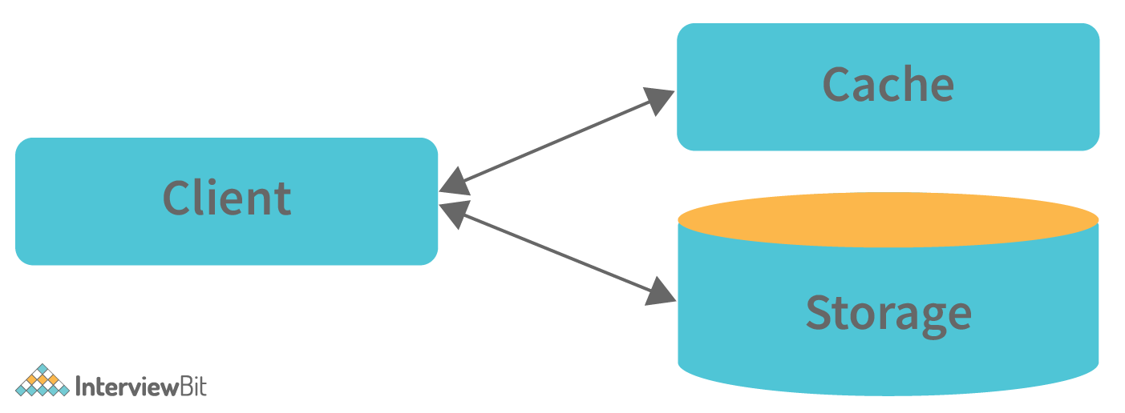
- Cache-aside: In this strategy, our application is responsible to write and read data from the storage. Cache interaction with the storage is not direct. Here, the application looks for an entry in the cache, if the result is not found, then the entry is fetched from the database and is added to the cache for further use. Memcached is an example of using this update strategy.
Cache-aside strategy is also known as lazy loading because only the requested entry will be cached thereby avoiding unnecessary caching of the data. Some of the disadvantages of this strategy are:
- In cases of a cache miss, there would be a noticeable delay as it results in fetching data from the database and then caching it.
- The chances of data being stale are more if it is updated in the database. This can be reduced by defining the time-to-live parameter which forces an update of the cache entry.
- When a cache node fails, it will be replaced by a new, empty node which results in increased latency.
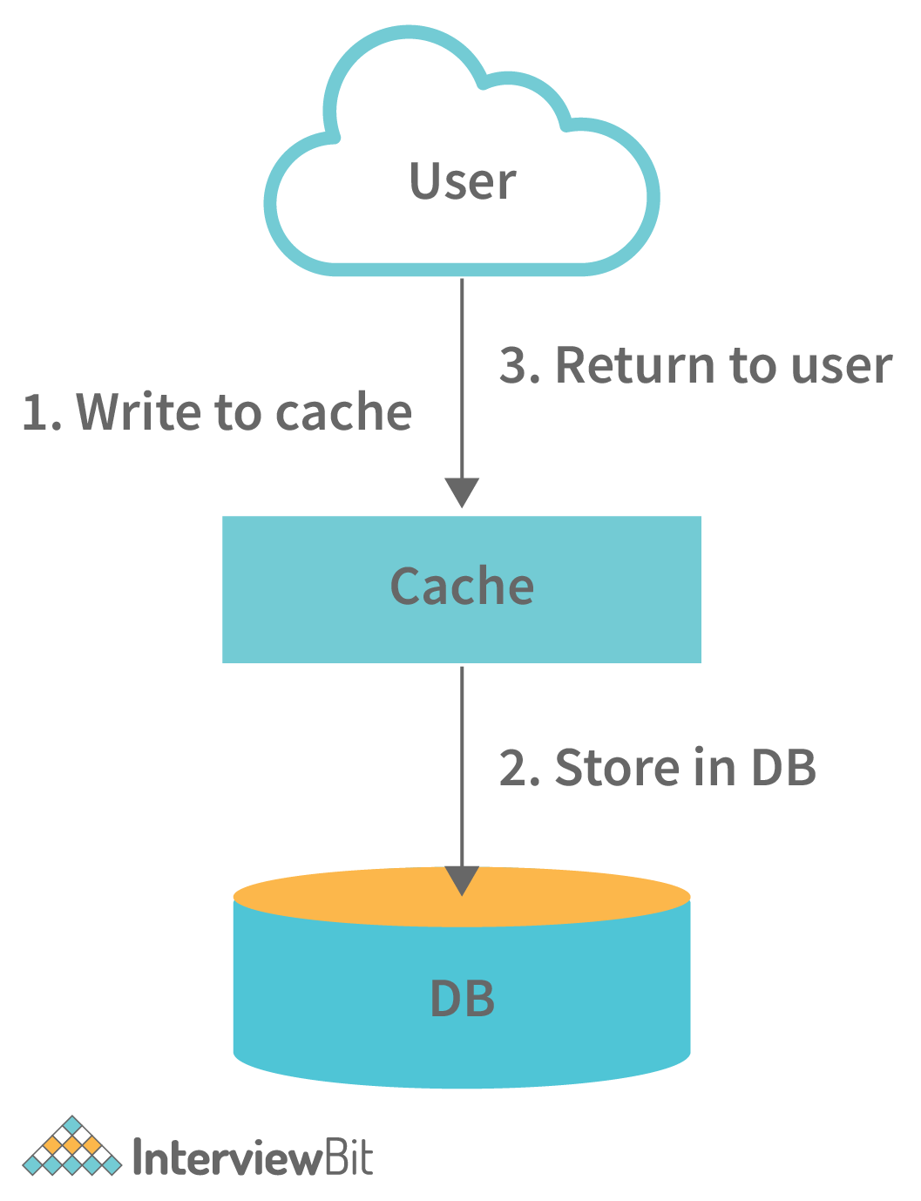
- Write-through: In this strategy, the cache will be considered as the main data store by the system and the system reads and writes data into it. The cache then updates the database accordingly as shown in the database.
- The system adds or updates the entry in the cache.
- The cache synchronously writes entries to the database. This strategy is overall a slow operation because of the synchronous write operation. However, the subsequent reads of the recently written data will be very fast. This strategy also ensures that the cache is not stale. But, there are chances that the data written in the cache might never be read. This issue can be reduced by providing appropriate TTL.
- Write-behind (write-back): In this strategy, the application does the following steps:
  - Add or update an entry in the cache
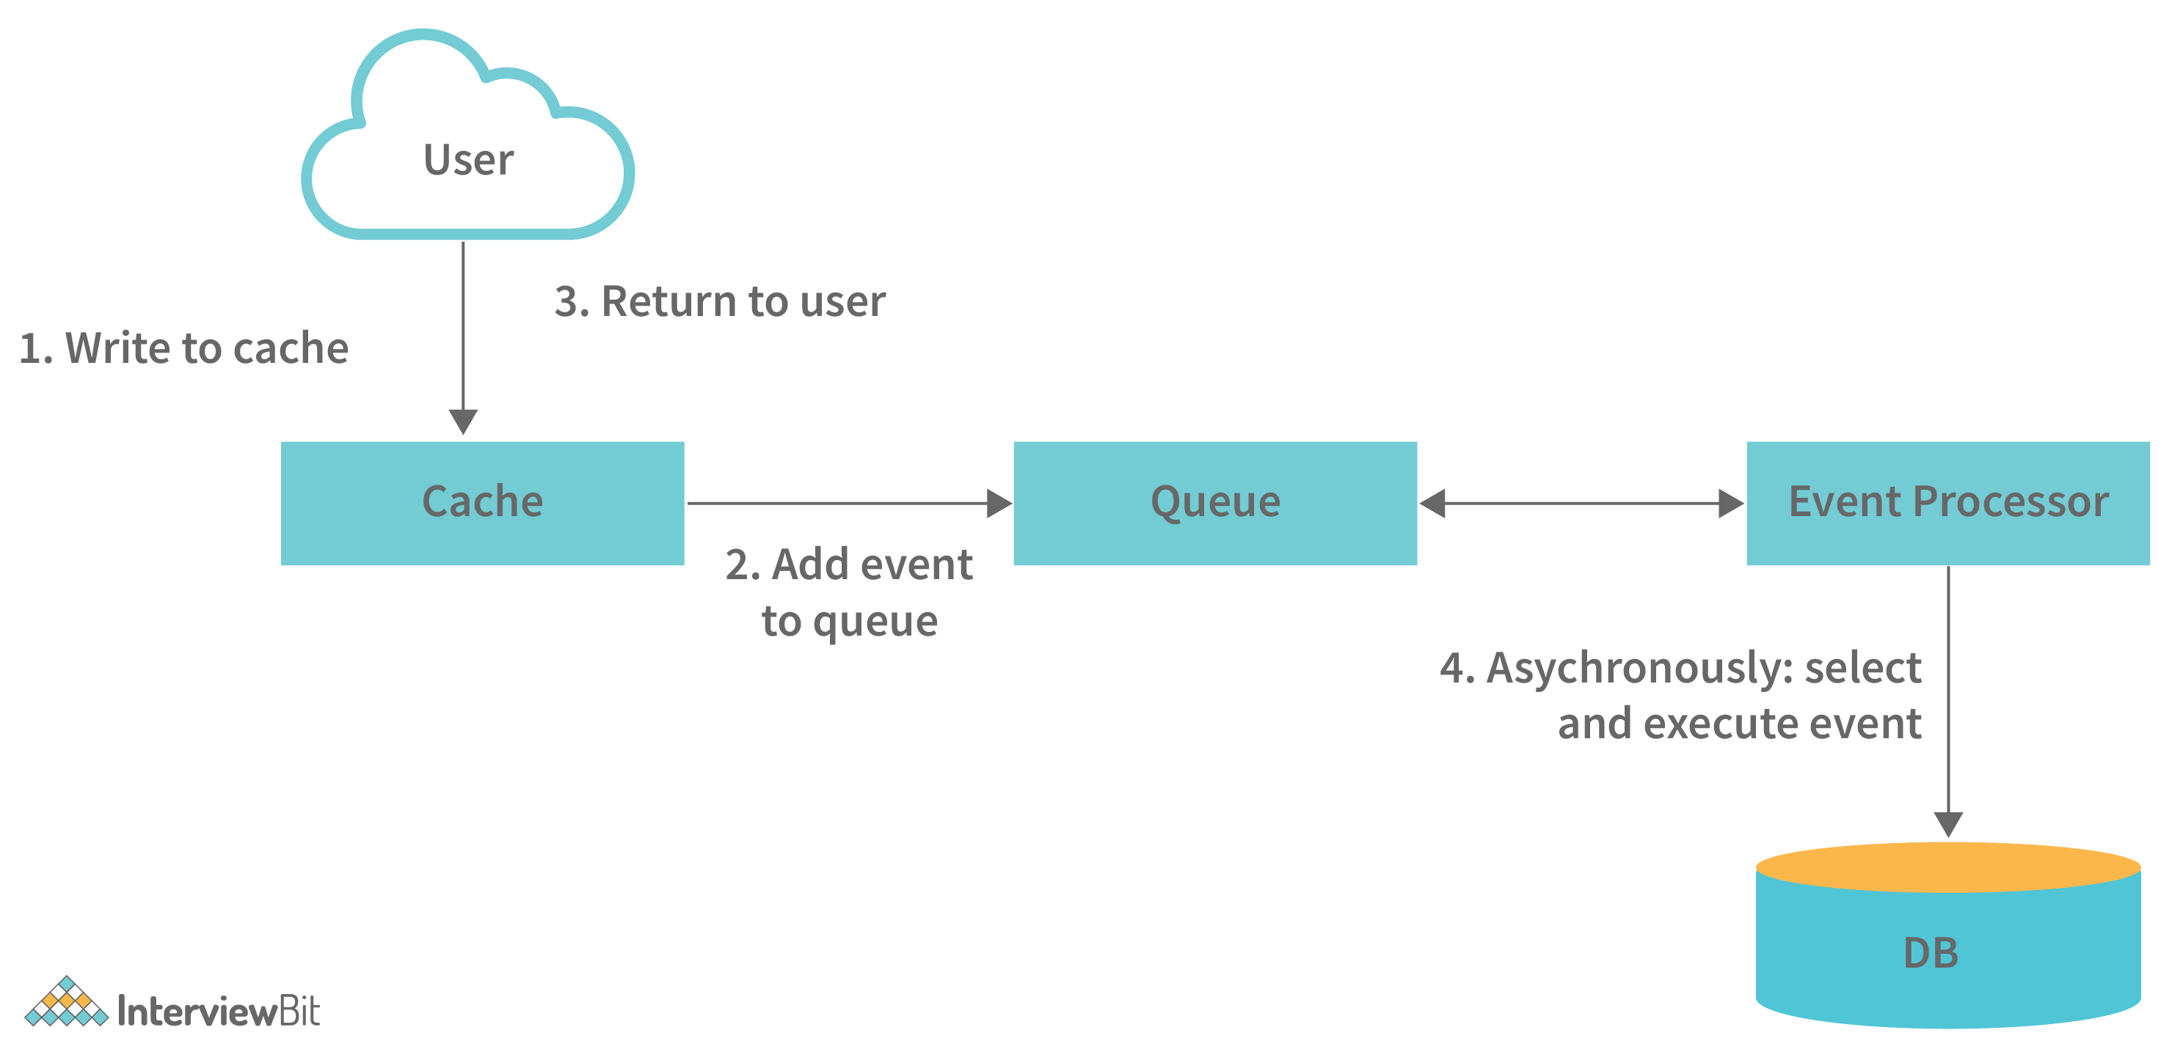
  - Write the entry into the data store asynchronously for improving the write performance. This is demonstrated in the image below:
The main disadvantage of this method is that there are chances of data loss if the cache goes down before the contents of the cache are written into the database.
- Refresh-ahead: Using this strategy, we can configure the cache to refresh the cache entry automatically before its expiration.
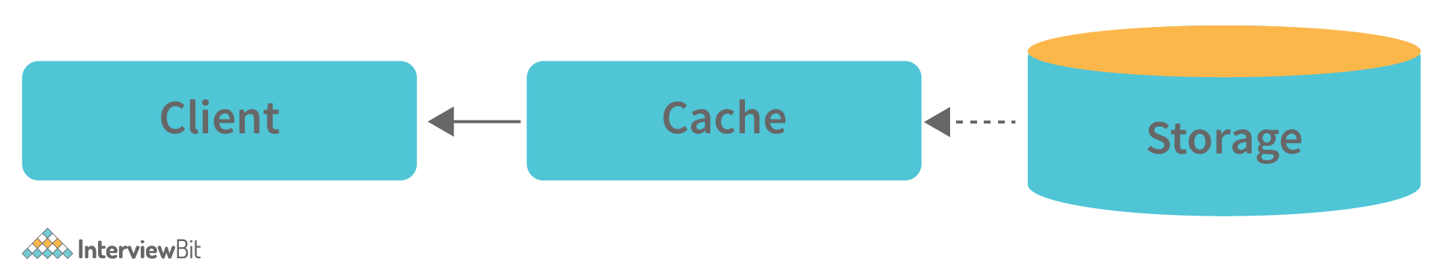
This cache strategy results in reduced latency if it can predict accurately what items are needed in future.

10. What are the various Consistency patterns available in system design?
Consistency from the CAP theorem states that every read request should get the most recently written data. When there are multiple data copies available, there arises a problem of synchronizing them so that the clients get fresh data consistently. Following are the consistency patterns available:
- Weak consistency: After a data write, the read request may or may not be able to get the new data. This type of consistency works well in real-time use cases like VoIP, video chat, real-time multiplayer games etc. For example, when we are on a phone call, if we lose network for a few seconds, then we lose information about what was spoken during that time.
- Eventual consistency: Post data write, the reads will eventually see the latest data within milliseconds. Here, the data is replicated asynchronously. These are seen in DNS and email systems. This works well in highly available systems.
- Strong consistency: After a data write, the subsequent reads will see the latest data. Here, the data is replicated synchronously. This is seen in RDBMS and file systems and are suitable in systems requiring transactions of data.

11. What do you understand by Content delivery network?
Content delivery network or in short CDN is a globally distributed proxy server network that serves content from locations close by to the end-users. Usually, in websites, static files like HTML, CSS, JS files, images and videos are served from CDN.
Using CDN in delivering content helps to improve performance:
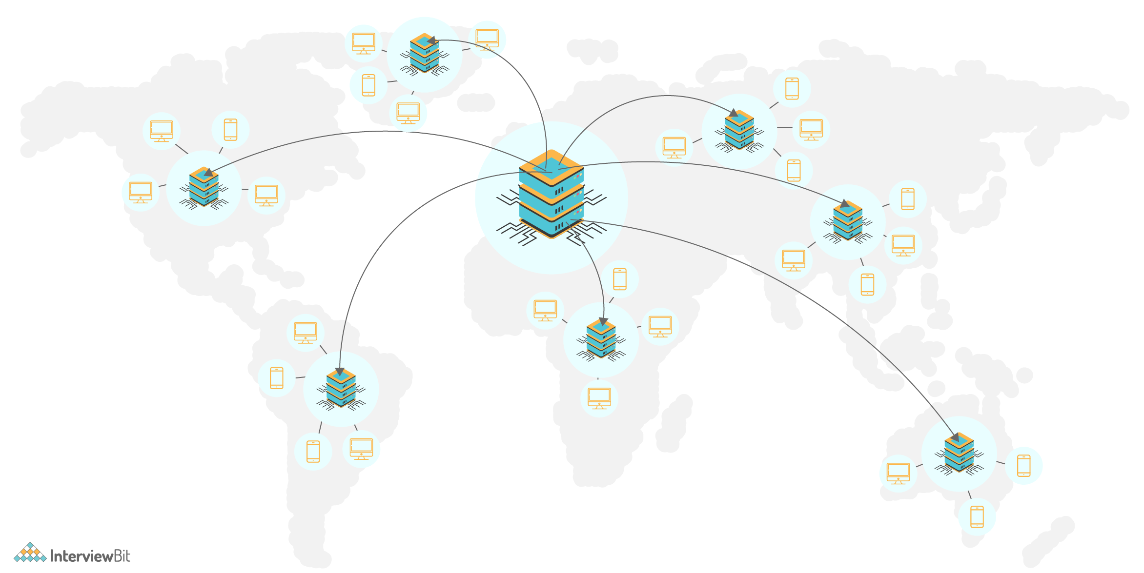
- Since users receive data from centres close to them as shown in the image below, they don't have to wait for long.
- Load on the servers is reduced significantly as some of the responsibility is shared by CDNs.
There are two types of CDNs, they are:
- Push CDNs: Here, the content is received by the CDNs whenever changes occur on the server. The responsibility lies in us for uploading the content to CDNs. Content gets updated to the CDN only when it is modified or added which in turn maximises storage by minimising the traffic. Generally, sites with lesser traffic or content work well using push CDNs.
- Pull CDNs: Here new content is grabbed from the server when the first user requests the content from the site. This leads to slower requests for the first time till the content gets stored/cached on the CDN. These CDNs minimizes space utilized on CDN but can lead to redundant traffic when expired files are pulled before they are changed. Websites having heavy traffic work well when used with pull CDNs.

12. What do you understand by Leader Election?
In a distributed environment where there are multiple servers contributing to the availability of the application, there can be situations where only one server has to take lead for updating third party APIs as different servers could cause problems while using the third party APIs. This server is called the primary server and the process of choosing this server is called leader election. The servers in the distributed environment have to detect when the leader server has failed and appoint another one to become a leader. This process is most suitable in high availability and strong consistency based applications by using a consensus algorithm.

13. How do you answer system design interview questions?
- Ask questions to the interviewer for clarification: Since the questions are purposefully vague, it is advised to ask relevant questions to the interviewer to ensure that both you and the interviewer are on the same page. Asking questions also shows that you care about the customer requirements.
- Gather the requirements: List all the features that are required, what are the common problems and system performance parameters that are expected by the system to handle. This step helps the interviewer to see how well you plan, expect problems and come up with solutions to each of them. Every choice matters while designing a system. For every choice, at least one pros and cons of the system needs to be listed.
- Come up with a design: Come up with a high-level design and low-level design solutions for each of the requirements decided. Discuss the pros and cons of the design. Also, discuss how they are beneficial to the business.
The primary objective of system design interviews is to evaluate how well a developer can plan, prioritize, evaluate various options to choose the best possible solution for a given problem.

14. What are some of the design issues in distributed systems?
Following are some of the issues found in distributed systems:
- Heterogeneity: The Internet allows applications to run over a heterogeneous collection of computers and networks. There would be different types of networks and the differences are masked by the usage of standard Internet protocols for communicating with each other. This becomes an issue while designing distributed applications
- Openness: Openness represents the measure by which a system can be extended and re-implemented in different ways. In distributed systems, it specifies the degree to which new sharing services can be added and made available for client usage.
- Security: The information maintained in distributed systems need to be secure as they are valuable to the users. The confidentiality, availability and integrity of the distributed systems have to be maintained and this sometimes becomes a challenge.
- Scalability: A system is scalable if it remains effective when there is a significant increase in the request traffic and resources. Designing a distributed system involves planning well in advance how well the system can be made scalable under varying user loads.
- Failure Handling: In a distributed environment, the failures are partial, meaning if some components fail, others would still function. It becomes challenging to handle these failures as it involves identifying right components where the failures occur.

System Design Interview Questions for Experienced

1. Design Uber, Ola or Lyft type of systems.
These platforms help user request rides and the driver picks them up from the location and drop them at the destination selected by the user.
- What are some of the required features?
  - Real-time service for booking rides
  - Should have the capability of assigning rides that lets the user reach the destination fast.
  - Show the ETA (Estimated Time of Arrival) of the driver after booking the ride and once the ride has been started, show the ETA of the vehicle arriving at the destination.
- What are some of the common problems encountered?
  - How to store geographical locations for drivers always on move?
  - How to assign drivers to the customers efficiently?
  - How do you calculate the ETA of the driver arrival or the destination arrival?
- Possible tips for consideration:
  - Make use of the microservices concept with fast databases for booking rides faster.
  - Evaluate Dispatch System for assigning drivers to the users.

There’s also a MCQ test here,
https://www.interviewbit.com/system-design-interview-questions/
(free interactive MCQ :)

Information Design Interview Questions and Answers
What is information design and why is it important?
  - Answer: Information design is the strategic process of organizing, presenting, and communicating information effectively to a specific audience. It aims to make complex data understandable, accessible, and engaging, leading to better decision-making, increased learning, and improved user experiences. Its importance lies in its ability to clarify, simplify, and enhance the comprehension of information, ensuring it serves its intended purpose.
- Explain the difference between information design and graphic design.
  - Answer: While both disciplines focus on visual communication, information design prioritizes the clarity and effectiveness of information delivery, while graphic design focuses on aesthetics and visual appeal. Information design emphasizes understanding the user's needs and goals, crafting the most appropriate visual structure to convey information, while graphic design might prioritize visual impact and brand consistency. Information design often informs graphic design choices, but not vice versa.
- What are some key principles of information design?
  - Answer: Key principles of information design include:
  - Clarity: Presenting information in a straightforward and unambiguous manner, avoiding jargon or ambiguity.
  - Conciseness: Using concise language and visuals, eliminating unnecessary elements that might distract or confuse the audience.
  - Consistency: Maintaining a consistent visual language, typography, and layout throughout the design, ensuring familiarity and ease of navigation.
  - Hierarchy: Establishing a clear visual hierarchy, prioritizing important information and guiding the user's attention.
  - Accessibility: Designing for diverse users, considering accessibility needs like color contrast, font size, and alternative text for images.
  - Usability: Ensuring that the design is intuitive and easy to use, with clear navigation and interaction points.
- Describe the process of conducting user research for an information design project.
  - Answer: User research is crucial for understanding the target audience's needs, preferences, and existing knowledge. It involves:
  - Defining research goals: Identifying specific questions to be answered through research.
  - Choosing research methods: Selecting appropriate techniques like user interviews, surveys, usability testing, or field observation.
  - Recruiting participants: Identifying and recruiting a representative sample of users.
  - Collecting data: Conducting the chosen research methods and documenting findings.
  - Analyzing data: Identifying patterns, insights, and key takeaways from the research.
  - Synthesizing findings: Presenting the research results in a clear and concise way, including actionable recommendations.
- What are some common information design tools and software?
  - Answer: Common information design tools include:
  - Data visualization tools: Tableau, Power BI, D3.js, Adobe Illustrator, Figma, Sketch, etc.
  - Wireframing and prototyping tools: Figma, Sketch, Adobe XD, InVision Studio, Balsamiq.
  - Presentation software: PowerPoint, Google Slides, Keynote.
  - Content management systems (CMS): WordPress, Drupal, Joomla.
- Explain the concept of information architecture and its importance in information design.
  - Answer: Information architecture (IA) is the structured organization and labeling of information within a website or any digital product. It determines the structure, navigation, and labeling systems to ensure users can easily find and understand the content they need. Its importance in information design lies in its ability to create intuitive user experiences, improve content discoverability, and enhance the overall usability of a product.
- How do you choose the right visual language for an information design project?
  - Answer: Selecting the appropriate visual language depends on the audience, the message, and the desired impact. Factors to consider include:
  - Target audience: Understanding their age, education, cultural background, and information-processing preferences.
  - Content type: Choosing visual elements suitable for the type of information being presented (e.g., charts for data, diagrams for processes, icons for symbols).
  - Communication goals: Deciding whether to emphasize clarity, engagement, or persuasion, and choosing visuals accordingly.
  - Brand identity: Maintaining consistency with existing brand guidelines and visual elements.
  - Accessibility: Ensuring that the visual language is accessible to all users, including those with disabilities.
- What is the role of color in information design?
  - Answer: Color plays a significant role in information design, influencing perception, attention, and emotions. It can be used to:
  - Highlight important elements: Using contrasting colors to draw attention to key information.
  - Categorize information: Grouping related information using consistent color schemes.
  - Create visual hierarchy: Using color to differentiate levels of importance within the design.
  - Evoke emotions: Using color psychology to create specific feelings (e.g., calm with blue, excitement with red).
  - Improve accessibility: Ensuring sufficient color contrast for users with visual impairments.
- How do you measure the effectiveness of your information design work?
  - Answer: Measuring the effectiveness of information design can involve:
  - Usability testing: Observing users interacting with the design to identify usability issues and gather feedback.
  - Surveys and questionnaires: Collecting quantitative and qualitative data on user satisfaction, comprehension, and recall.
  - A/B testing: Comparing different design versions to identify the most effective solution.
  - Tracking user behavior: Analyzing data on user engagement, navigation patterns, and time spent on specific elements.
  - Collecting feedback from stakeholders: Gathering insights from clients, colleagues, and other involved parties.
- What are some emerging trends in information design?
  - Answer: Emerging trends in information design include:
  - Data storytelling: Using data visualization to create engaging narratives and insights.
  - Interactive information design: Incorporating interactive elements to enhance user engagement and understanding.
  - Artificial intelligence (AI) in design: Utilizing AI tools for data analysis, visualization, and design automation.
  - Design for accessibility: Prioritizing inclusive design principles to cater to a wider range of users.
  - Sustainable design: Considering the environmental impact of design choices and promoting responsible practices.
- Tell us about a time you had to communicate complex information to a non-technical audience.
  - Answer: [Describe a specific situation where you successfully communicated complex information to a non-technical audience. Highlight the methods you used to simplify the information, the visual aids you employed, and the positive outcome of your efforts.]
- How do you stay up-to-date with the latest trends and advancements in information design?
  - Answer: [Explain your methods of staying informed about information design trends, including reading industry publications, attending conferences and workshops, following influential designers on social media, and engaging in online communities.]
- What are your strengths and weaknesses as an information designer?
  - Answer: [Identify your key strengths as an information designer, such as strong visual communication skills, user empathy, data analysis abilities, or proficiency in design tools. Be honest about your weaknesses, but also mention how you are working to improve them.]
- Why are you interested in pursuing a career in information design?
  - Answer: [Share your personal motivation for pursuing a career in information design, highlighting your passion for making complex information accessible and your desire to contribute to positive user experiences.]
- What are your salary expectations?
  - Answer: [Research the average salary range for entry-level information design positions in your area. Be prepared to state your expectations clearly and confidently, but also be flexible and willing to negotiate.]
- Do you have any questions for us?
  - Answer: [Prepare insightful questions about the company, the role, or the team. This demonstrates your genuine interest and shows that you've done your research.]
- Describe a time you had to overcome a design challenge.
  - Answer: [Share a specific experience where you faced a design challenge and describe how you approached it. Explain the steps you took to find a solution, the skills you used, and the outcome of your efforts.]
- How do you handle criticism and feedback on your work?
  - Answer: [Demonstrate your ability to accept feedback constructively and use it to improve your work. Explain how you remain open to different perspectives and use criticism as an opportunity for growth.]
- What are your favorite information design projects or websites?
  - Answer: [Share specific examples of information design projects or websites that you admire. Explain why you find them compelling, highlighting the design principles or techniques you appreciate.]
- How do you ensure your information design work is accessible to users with disabilities?
  - Answer: [Explain your understanding of accessibility guidelines and best practices in information design. Describe how you incorporate these principles into your work to create inclusive and accessible experiences for all users.]
- What is your preferred method for collaborating with other designers and stakeholders?
  - Answer: [Describe your collaborative style and preferred communication methods. Explain how you value open communication, feedback, and the ability to work effectively as part of a team.]
- Explain the difference between quantitative and qualitative data in information design.
  - Answer: [Define quantitative and qualitative data, explaining their distinct characteristics and uses in information design. Provide examples of each type of data and how they contribute to understanding user behavior and design decisions.]
- How do you ensure your information design work is culturally sensitive?
  - Answer: [Explain your understanding of cultural sensitivity in information design. Describe how you research and consider the cultural contexts of your target audience, adapting design elements to avoid misunderstandings or offensive representations.]
- What is your understanding of the ethical considerations in information design?
  - Answer: [Discuss your understanding of ethical considerations in information design, including issues related to data privacy, bias, misinformation, and accessibility. Explain how you strive to create designs that are responsible, ethical, and beneficial to users.]
- How would you design an infographic to explain a complex scientific concept to a general audience?
  - Answer: [Describe a step-by-step approach to designing an infographic for a complex scientific concept. Explain your choices of visual elements, data representation, and storytelling techniques to ensure clarity, engagement, and comprehension for a broad audience.]
- What are some best practices for designing user interfaces (UIs) that prioritize information design principles?
  - Answer: [Outline best practices for UI design that incorporate information design principles, focusing on clarity, consistency, hierarchy, and accessibility. Provide specific examples of UI elements and design decisions that prioritize information clarity and user understanding.]
- How do you use data visualization techniques to communicate insights effectively?
  - Answer: [Explain your knowledge of data visualization techniques and their application in information design. Discuss different chart types, their strengths and weaknesses, and how you choose the most appropriate visual representation for different data sets and communication goals.]
- What are some common pitfalls to avoid when creating information design projects?
  - Answer: [Identify common pitfalls in information design, such as cluttered visuals, confusing navigation, poor color choices, lack of accessibility, or neglecting user research. Explain how to avoid these pitfalls and create effective, user-friendly designs.]
- How do you stay motivated and inspired as an information designer?
  - Answer: [Describe your sources of inspiration and motivation as an information designer. Share your interests, hobbies, or design communities that help you stay passionate and engaged in the field.]
- What is your approach to learning new design tools and software?
  - Answer: [Explain your learning style and approach to acquiring new skills in design tools and software. Share your preferred learning resources, such as online tutorials, courses, or practice projects.]
- How would you design an information system for a specific user group, such as senior citizens or people with low literacy skills?
  - Answer: [Describe a tailored approach to designing an information system for a specific user group with unique needs. Explain your considerations for accessibility, readability, navigation, and visual elements to ensure the system is effective and easy to use for the target audience.]
- What is your understanding of user experience (UX) design and its relevance to information design?
  - Answer: [Explain your understanding of UX design and its importance in creating positive user experiences. Discuss how UX principles like usability, accessibility, and satisfaction are intertwined with information design to create effective and engaging products.]
- How would you design a data visualization to show the impact of climate change on global temperatures over time?
  - Answer: [Describe a specific approach to designing a data visualization for climate change data. Explain your choice of chart type, visual elements, color schemes, and storytelling techniques to effectively communicate the trends and impact of climate change on global temperatures.]
- Explain the concept of information hierarchy and how you would apply it in a website design.
  - Answer: [Define information hierarchy and its role in guiding user attention and understanding. Explain how you would implement information hierarchy principles in a website design, using elements like headings, font sizes, colors, and visual prominence to prioritize important content and create a clear navigation structure.]
- What are some common types of information graphics, and how do you choose the best type for a specific project?
  - Answer: [Identify common types of information graphics, such as infographics, charts, diagrams, maps, and timelines. Explain the strengths and weaknesses of each type and how you would select the most appropriate graphic for specific content, audience, and communication goals.]
- How do you use typography effectively in information design?
  - Answer: [Explain your understanding of typography and its role in information design. Discuss font choices, font sizes, spacing, and other typographic elements that contribute to readability, hierarchy, and visual appeal in information graphics and web designs.]
- What is your understanding of design systems and their benefits in information design?
  - Answer: [Define design systems and explain their benefits in information design, including consistency, scalability, efficiency, and accessibility. Describe how design systems streamline design processes, maintain brand coherence, and ensure user experience consistency across various products and platforms.]
- How do you incorporate user feedback and iterate on your information design solutions?
  - Answer: [Describe your iterative design process and how you incorporate user feedback. Explain your methods for gathering user feedback, analyzing data, and iterating on designs to improve usability, accessibility, and overall effectiveness.]
- What is your preferred method for presenting information design work to clients and stakeholders?
  - Answer: [Explain your preferred method for presenting information design work, including the use of prototypes, wireframes, mockups, or interactive presentations. Discuss your approach to communicating design decisions, addressing feedback, and ensuring clear understanding of the proposed solutions.]
- How do you balance the need for visual appeal with the need for information clarity in information design?
  - Answer: [Explain your approach to balancing visual appeal and information clarity in information design. Describe your strategies for using visual elements effectively to enhance engagement and comprehension without sacrificing the clarity and accessibility of information.]
- What are your thoughts on the future of information design?
  - Answer: [Share your insights and predictions about the future of information design, considering emerging technologies, trends in data visualization, and the evolving needs of users in a digital world. Discuss potential areas of growth, innovation, and challenges within the field.]
- Describe your experience with using data visualization tools to create interactive dashboards or reports.
  - Answer: [Share your experience with using data visualization tools like Tableau, Power BI, or D3.js. Explain your proficiency in creating interactive dashboards or reports, highlighting specific projects or examples where you effectively visualized data to communicate insights and trends.]
- What is your preferred method for gathering user requirements and translating them into design solutions?
  - Answer: [Describe your process for gathering user requirements, including techniques like user interviews, surveys, and user observation. Explain how you analyze user needs and translate them into design solutions that address those requirements and achieve project goals.]
- How do you stay informed about accessibility guidelines and best practices in information design?
  - Answer: [Explain your methods for staying updated on accessibility guidelines, such as following industry publications, attending workshops, and consulting with accessibility experts. Describe your commitment to creating inclusive and accessible designs for all users.]
- Describe a time you had to explain a complex design concept to a non-designer stakeholder.
  - Answer: [Share a specific experience where you effectively explained a design concept to a non-designer stakeholder. Explain the techniques you used to communicate complex ideas in a clear and understandable way, using visuals, analogies, and simple language.]
- How do you approach the design of a user interface for a mobile application?
  - Answer: [Describe your approach to mobile UI design, considering factors like screen size, touch interaction, and navigation patterns. Explain how you optimize designs for mobile devices, ensuring usability, accessibility, and a positive user experience.]
- What are your thoughts on the use of micro-interactions in information design?
  - Answer: [Discuss your understanding of micro-interactions and their role in enhancing user engagement and providing feedback. Explain how you would incorporate micro-interactions into information design projects to create delightful and intuitive user experiences.]
- How do you think information design can contribute to solving social or environmental problems?
  - Answer: [Share your perspective on the potential of information design to address social or environmental issues. Discuss how clear communication, data visualization, and engaging narratives can raise awareness, promote understanding, and inspire action towards positive change.]
- What is your understanding of the role of storytelling in information design?
  - Answer: [Explain your understanding of storytelling as a powerful tool in information design. Describe how you can use narrative structures, engaging visuals, and emotional appeal to create compelling stories that resonate with users and enhance their understanding of complex information.]
- How would you design an information system to help people understand their personal finances?
  - Answer: [Describe a specific approach to designing a financial information system. Explain your choice of data visualization techniques, user interface elements, and navigation structures to create a clear, intuitive, and engaging system that empowers users to manage their finances effectively.]
- What is your experience with using prototyping tools to create interactive prototypes for information design projects?
  - Answer: [Share your experience with using prototyping tools like Figma, Sketch, or Adobe XD. Describe your proficiency in creating interactive prototypes to test design ideas, gather user feedback, and iterate on solutions before implementation.]
- How do you approach the design of information systems that need to adapt to different screen sizes and devices?
  - Answer: [Explain your approach to designing responsive information systems that work seamlessly across various devices. Discuss your considerations for screen sizes, navigation, and layout optimization to create user experiences that are consistent and engaging across different platforms.]
- What is your understanding of the concept of information scent and its importance in information design?
  - Answer: [Define information scent and explain its significance in guiding users towards their desired information. Discuss how information scent is created through clear labeling, intuitive navigation, and consistent design patterns to help users find the information they need efficiently and effectively.]
- How do you use animation and motion graphics to enhance the user experience in information design projects?
  - Answer: [Explain your understanding of animation and motion graphics as tools for engaging users and enhancing comprehension. Discuss how you use animation techniques strategically to guide attention, highlight key information, and create dynamic and memorable user experiences.]
- What are some ethical considerations when designing information systems that collect and analyze user data?
  - Answer: [Discuss ethical considerations related to user data collection and analysis in information design projects. Explain the importance of privacy, transparency, and informed consent in ensuring responsible and ethical practices.]
- Describe your experience with using content management systems (CMS) to manage and publish information design projects.
  - Answer: [Share your experience with using CMS platforms like WordPress, Drupal, or Joomla. Explain your proficiency in managing content, creating templates, and publishing information design projects for various platforms.]
- How do you approach the design of information systems for complex and interconnected data sets?
  - Answer: [Describe your strategy for designing information systems for complex data sets, focusing on techniques for organizing, visualizing, and navigating large amounts of information. Discuss your use of data hierarchy, filtering tools, and interactive elements to create systems that are manageable and understandable for users.]
- What are your thoughts on the use of gamification in information design projects?
  - Answer: [Discuss your understanding of gamification and its potential applications in information design. Explain how gamification techniques like points, badges, and leaderboards can enhance user engagement, motivation, and learning outcomes.]
- How do you think information design can contribute to improving communication and understanding across cultural boundaries?
  - Answer: [Share your perspective on the role of information design in bridging cultural gaps. Discuss how visual communication, accessible language, and culturally sensitive design choices can facilitate communication and understanding across diverse cultures.]
- Describe your experience with conducting usability testing and using user feedback to improve information design solutions.
  - Answer: [Share your experience with conducting usability testing, including planning, participant recruitment, testing procedures, and data analysis. Explain how you use user feedback to identify usability issues, iterate on designs, and improve the overall user experience.]
- How do you incorporate user feedback into the iterative design process for information design projects?
  - Answer: [Explain your approach to incorporating user feedback into the iterative design process, emphasizing the importance of collecting data, analyzing findings, and making adjustments to designs based on user needs and preferences.]
- What are your thoughts on the ethical implications of using artificial intelligence (AI) in information design?
  - Answer: [Discuss your understanding of the ethical implications of using AI in information design, considering potential biases, data privacy concerns, and the impact on human creativity. Share your perspective on the responsible use of AI to enhance information design while upholding ethical principles.]
- Describe your experience with using design systems to create consistent and scalable information design solutions.
  - Answer: [Share your experience with using design systems, outlining your understanding of their components like style guides, component libraries, and design principles. Explain how you leverage design systems to maintain consistency, improve efficiency, and ensure scalability in information design projects.]
- How do you stay updated with emerging trends and technologies in information design?
  - Answer: [Explain your methods for staying informed about emerging trends and technologies in information design, including attending conferences, reading industry publications, following design communities, and experimenting with new tools and techniques.]
- What are your thoughts on the potential of augmented reality (AR) and virtual reality (VR) in enhancing information design experiences?
  - Answer: [Discuss your understanding of AR and VR technologies and their potential applications in information design. Explain how these technologies can create immersive experiences, enhance engagement, and provide new ways to interact with information.]
- How do you think information design can contribute to promoting social justice and equality?
  - Answer: [Share your perspective on the potential of information design to promote social justice and equality. Discuss how inclusive design practices, accessibility considerations, and responsible data visualization can contribute to creating a more equitable and just society.]
- Describe your experience with working on information design projects that involve collaboration with cross-functional teams.
  - Answer: [Share your experience with collaborating with cross-functional teams, highlighting your communication skills, ability to work effectively with diverse perspectives, and your contributions to collaborative design processes.]
- How do you balance the need for data accuracy with the need for visual appeal in information design?
  - Answer: [Explain your approach to balancing data accuracy and visual appeal in information design. Discuss your strategies for ensuring data integrity while using visual elements effectively to enhance comprehension and engagement.]
- What are your thoughts on the use of user research to inform the design process for information systems?
  - Answer: [Discuss your understanding of user research and its importance in information design. Explain how user research helps you gain valuable insights into user needs, preferences, and behaviors, leading to more effective and user-centric design solutions.]
- How do you approach the design of information systems that are intended for international audiences?
  - Answer: [Describe your approach to designing information systems for international audiences, considering cultural differences, language variations, and global accessibility standards. Discuss your strategies for localization, translation, and adapting design elements to ensure a positive user experience for diverse global users.]
- What is your understanding of the role of data ethics in information design?
  - Answer: [Discuss your understanding of data ethics in information design, focusing on principles like data privacy, transparency, and responsible use of data. Explain how you consider ethical implications when designing information systems that collect, analyze, and visualize user data.]
- Describe your experience with designing information systems for specific industries or sectors, such as healthcare, finance, or education.
  - Answer: [Share your experience with designing information systems for specific industries, highlighting your understanding of industry-specific needs, data requirements, and user expectations.]
- How do you approach the design of information systems that are intended for users with limited technical skills?
  - Answer: [Describe your approach to designing information systems for users with limited technical skills. Discuss your considerations for intuitive navigation, clear labeling, and simplified user interfaces to create systems that are accessible and easy to use for a wider range of users.]
- What are your thoughts on the use of interactive data visualization to promote user engagement and understanding?
  - Answer: [Discuss your understanding of interactive data visualization and its potential to enhance user engagement and understanding. Explain how interactive elements like filters, zoom controls, and drill-down features can empower users to explore data, discover insights, and personalize their experiences.]

12 Systems Analyst interview questions and answers (upwork)

1. Can You Describe Your Experience with Business Process Modeling and Analysis?
Business systems analysts need to be proficient in business process modeling and analysis. The hiring manager wants to know about your experience in this area.
How to Answer:
Discuss your experience with business process modeling and analysis, including the tools and methodologies you've used, such as BPMN, flowcharts, or swimlane diagrams. Share examples of projects where you've successfully modeled and analyzed business processes.

2. How Do You Identify and Communicate System Requirements to Technical Teams?
Communicating business needs and technical requirements is a must for this position, and hiring managers want to know your capabilities.
How to Answer:
﻿
Explain your process for identifying system requirements, such as gathering stakeholder information, analyzing business processes, and reviewing existing systems. Discuss how you communicate these requirements to technical teams using techniques like user stories, use cases, or functional specifications.

3. Can You Describe a Time When You Identified a System Issue and Proposed a Solution?
Problem-solving is a key skill for business systems analysts. The hiring manager wants to know your ability to identify issues and propose solutions.
How to Answer:
﻿
Describe a time when you identified a system issue, the steps you took to analyze the problem, the solution you proposed, and the outcome.

4. How Do You Stay Current with Technology Trends and Best Practices?
Staying current with technology trends and best practices is essential for business systems analysts, and hiring managers want to know how you stay informed.
How to Answer:
﻿
Discuss your methods for staying current on technology trends and best practices. Examples include attending conferences, taking online courses, reading industry publications, and participating in professional organizations to broaden your horizons. Mention any specific resources you find particularly helpful.

5. Can You Explain the Importance of Stakeholder Management in Your Role as a Business Systems Analyst?
Effective stakeholder management is crucial for a business systems analyst. The hiring manager wants to know how you handle this aspect of your role.
How to Answer:
﻿
Explain the importance of stakeholder management as a business systems analyst, such as gathering requirements, managing expectations, and ensuring successful project outcomes. Share an example of a project where effective stakeholder management was critical to success.

6. How Do You Prioritize Multiple Projects or Requests with Competing Deadlines?
Business systems analysts often need to juggle multiple projects and requests. The hiring manager wants to know how you manage competing priorities.
How to Answer:
﻿
Describe the methods you use to prioritize multiple projects or requests with competing deadlines, such as evaluating the impact and urgency of each project, considering the availability of resources, and communicating with stakeholders to manage expectations. Share an example of how you successfully managed multiple competing priorities in a previous role.

7. Describe a Challenging Project You've Worked On and How You Overcame the Challenges.
While facing challenging problems is part of many jobs, business systems analysts must be particularly skilled in this aspect. This role requires determining existing challenges and creating problem-solving techniques to overcome them. Hiring managers want to know you have experience handling and resolving challenging projects.
How to Answer:
﻿
Share an example of a challenging project you've worked on, describing the challenges you have faced and steps you took to overcome them. Discuss the outcome of the project and highlight any lessons learned.

8. How Do You Approach User Acceptance Testing (UAT) for New Systems or Enhancements?
User acceptance testing is essential to a business systems analyst's role. The hiring manager wants to know how you approach this task.
How to Answer:
﻿
Explain your process for conducting user acceptance testing, such as developing test plans, coordinating with stakeholders, and facilitating testing sessions. Discuss how you ensure new systems or enhancements meet user requirements and address any issues identified during testing.

9. What is your experience with Methodologies, Agile or Waterfall?
Hiring managers want to know your familiarity with software development methodologies and how you've applied them.
How to Answer:
﻿
Discuss your experience with software development methodologies, such as Agile or Waterfall, and how you've used them as a business systems analyst. Share examples of projects where you've successfully applied these methodologies.

10. How Do You Handle Scope Creep or Changing Requirements During a Project?
Managing scope creep and changing requirements is a challenge business systems analysts often face. The hiring manager wants to know how you handle these situations.
How to Answer:
Describe your approach to managing scope creep or changing requirements during a project, such as setting clear expectations, maintaining open communication, and implementing change control processes. Share an example of a project where you successfully managed scope creep or changing requirements.

11. How Do You Balance Technical Expertise with Business Acumen in Your Role as a Business Systems Analyst?
Hiring managers want to know how you balance technical expertise and business acumen as a business systems analyst.
How to Answer:
﻿
Explain how you balance technical expertise with business acumen by staying current with technology trends and industry developments, understanding business goals and strategies, and effectively communicating with technical and non-technical stakeholders.

12. What Do You Enjoy Most About Your Work as a Business Systems Analyst?
Hiring managers want to know that you're passionate about your work and find it fulfilling.
How to Answer:
Discuss what aspects of working as a business systems analyst you enjoy the most, such as analyzing complex problems, collaborating with diverse teams, or helping organizations implement effective solutions. Share specific examples from your experience that demonstrate your enthusiasm for the role.

45 system design interview questions to ask systems designer applicants

Basic systems design interview questions to ask junior applicants
Ask applicants these systems design interview questions to learn if they have the basic system design skills and experience needed to join your business.
- Explain what the CAP theorem is.
- Explain what systems design is.
- Which factors are the most important for designing a system perfectly?
- What is the ideal tool for structured design?
- Define horizontal scaling.
- Define vertical scaling.
- Explain the difference between horizontal and vertical scaling.
- Describe your experience as a systems designer.
- Which systems design skill are you most proud of?
- Which systems design skills do you need to develop?
- Explain what load balancing means.
- Describe why load balancing is essential in systems design.
- Define system latency in systems design.
- Define throughput in the context of systems design.
- Define availability in the context of systems design.
- Explain what sharding means.
- Explain what partitioning means.
- Is there a difference between partitioning and sharding? Explain your answer.
- Describe the relationship between scalability and performance.
- Define caching and name two cache update strategies related to systems design.
- Tell me what you know about CDNs (content delivery networks).
- What is a push CDN?
- What is a pull CDN?
- Tell me what you know about leader election processes.
- Name three design issues you may encounter in distributed systems.
- Is there a difference between NoSQL and SQL databases? Explain your response.
How can you tell if your next systems designer fits your company well? Which method is ideal for discovering if they can identify, design, and build systems that align with your organization’s specific expectations?
Narrowing down the full range of skills you need to assess when hiring a systems designer can be overwhelming.
The good news is you can make the hiring process easier by giving candidates skills tests like our Project Management test and then following up with an interview.
You may find it challenging to select the most suitable interview questions to pinpoint the perfect candidate. Fortunately, we have a solution. Choose from this list of 45 systems design interview questions to hire the right systems designer for your team.

Table of contents
- Basic systems design interview questions to ask junior applicants
- 5 critical basic system design interview questions and answers
- Advanced systems design interview questions to ask senior applicants
- 5 critical advanced systems design interview questions and answers
- 5 systems design interview questions and answers related to skills and abilities
- What are the advantages of using skills assessments to hire systems designers?
- How should you incorporate skills testing into your hiring process?
- Why and how should you use skills testing for onboarding processes?
- Discover top systems designers with skills tests and systems design interview questions

Basic systems design interview questions to ask junior applicants
Ask applicants these systems design interview questions to learn if they have the basic system design skills and experience needed to join your business.
- Explain what the CAP theorem is.
- Explain what systems design is.
- Which factors are the most important for designing a system perfectly?
- What is the ideal tool for structured design?
- Define horizontal scaling.
- Define vertical scaling.
- Explain the difference between horizontal and vertical scaling.
- Describe your experience as a systems designer.
- Which systems design skill are you most proud of?
- Which systems design skills do you need to develop?
- Explain what load balancing means.
- Describe why load balancing is essential in systems design.
- Define system latency in systems design.
- Define throughput in the context of systems design.
- Define availability in the context of systems design.
- Explain what sharding means.
- Explain what partitioning means.
- Is there a difference between partitioning and sharding? Explain your answer.
- Describe the relationship between scalability and performance.
- Define caching and name two cache update strategies related to systems design.
- Tell me what you know about CDNs (content delivery networks).
- What is a push CDN?
- What is a pull CDN?
- Tell me what you know about leader election processes.
- Name three design issues you may encounter in distributed systems.
- Is there a difference between NoSQL and SQL databases? Explain your response.

5 critical basic system design interview questions and answers
How can you tell if your next systems designer fits your company well? Which method is ideal for discovering if they can identify, design, and build systems that align with your organization’s specific expectations?
Narrowing down the full range of skills you need to assess when hiring a systems designer can be overwhelming.
The good news is you can make the hiring process easier by giving candidates skills tests like our Project Management test and then following up with an interview.
You may find it challenging to select the most suitable interview questions to pinpoint the perfect candidate. Fortunately, we have a solution. Choose from this list of 45 systems design interview questions to hire the right systems designer for your team.

Table of contents
- Basic systems design interview questions to ask junior applicants
- 5 critical basic system design interview questions and answers
- Advanced systems design interview questions to ask senior applicants
- 5 critical advanced systems design interview questions and answers
- 5 systems design interview questions and answers related to skills and abilities
- What are the advantages of using skills assessments to hire systems designers?
- How should you incorporate skills testing into your hiring process?
- Why and how should you use skills testing for onboarding processes?
- Discover top systems designers with skills tests and systems design interview questions

Basic systems design interview questions to ask junior applicants
Ask applicants these systems design interview questions to learn if they have the basic system design skills and experience needed to join your business.
- Explain what the CAP theorem is.
- Explain what systems design is.
- Which factors are the most important for designing a system perfectly?
- What is the ideal tool for structured design?
- Define horizontal scaling.
- Define vertical scaling.
- Explain the difference between horizontal and vertical scaling.
- Describe your experience as a systems designer.
- Which systems design skill are you most proud of?
- Which systems design skills do you need to develop?
- Explain what load balancing means.
- Describe why load balancing is essential in systems design.
- Define system latency in systems design.
- Define throughput in the context of systems design.
- Define availability in the context of systems design.
- Explain what sharding means.
- Explain what partitioning means.
- Is there a difference between partitioning and sharding? Explain your answer.
- Describe the relationship between scalability and performance.
- Define caching and name two cache update strategies related to systems design.
- Tell me what you know about CDNs (content delivery networks).
- What is a push CDN?
- What is a pull CDN?
- Tell me what you know about leader election processes.
- Name three design issues you may encounter in distributed systems.
- Is there a difference between NoSQL and SQL databases? Explain your response.

5 critical basic system design interview questions and answers
Check the answers to these five essential basic system design interview questions when reviewing your applicants’ responses to assess their knowledge.
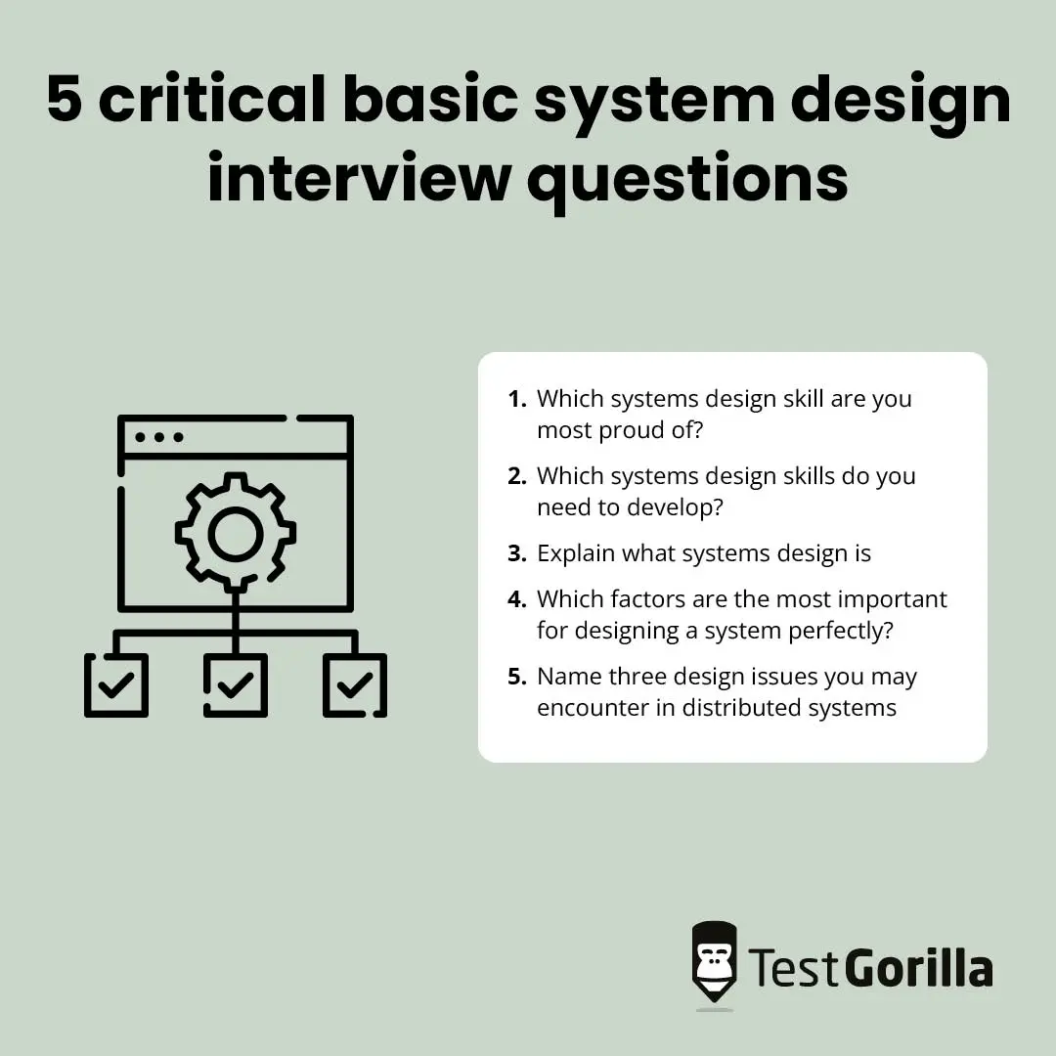

1. Which systems design skill are you most proud of?
This systems design interview question will prompt candidates to describe their strongest systems design skill or the one that helps them complete challenging work.
You may receive many answers that indicate applicants’ familiarity with systems design. The trick is to listen for responses that explain why the skills are important – the why is just as important as the what.
From database management to application development, skills related to systems design can help professionals create systems designs according to a company’s technical specifications.
Since database management skills are vital, consider evaluating your applicants’ abilities in this area with our Database Management and Administration test.

2. Which systems design skills do you need to develop?
Whether applicants lack knowledge of operating systems or IT skills related to systems design, they should always mention the methods and techniques they use to build and develop skills when responding to this systems design interview question.
As they respond, look for signs that they are continuously upskilling by completing courses such as a bachelor’s degree or building work experience.
If you’re searching for ways to assess the skills your candidates lack, look through our skills test library. Some system-design-related tests you may consider include our Windows Server Administration and Project Management tests.

3. Explain what systems design is
Systems design is a process in which system designers establish the elements of a system, including components and interfaces, system architecture, and modules. The process involves identifying, planning, and building systems that align with an organization’s objectives.
Skilled applicants may elaborate further and explain that system analysis, patterns in system architecture, and using APIs are the main priorities for systems designers. These responsibilities reduce maintenance and financial costs and enhance the end-user experience.

4. Which factors are the most important for designing a system perfectly?
There are more than 14,271 system design engineers in the US, and many are proficient in their field. If your applicants have experience with designing perfect systems, they should know that several factors facilitate the system design process, including the following:
- Ensuring the system is well documented
- Enhancing the user-friendly aspects of the system
- Building a system that can store its users’ data
- Creating a well-ranked system

5. Name three design issues you may encounter in distributed systems
Here are a few types of design issues applicants may mention when answering this systems design interview question:
- Security issues: Systems designers must maintain the confidentiality and integrity of distributed systems, which can be a difficult task
- Scalability issues: Systems designers should understand how to plan scalable distributed systems to handle varying user loads
- Openness issues: Systems designers need to know that systems should be capable of extension or re-implementation, including sharing new services for clients
How can you tell if your next systems designer fits your company well? Which method is ideal for discovering if they can identify, design, and build systems that align with your organization’s specific expectations?
Narrowing down the full range of skills you need to assess when hiring a systems designer can be overwhelming.
The good news is you can make the hiring process easier by giving candidates skills tests like our Project Management test and then following up with an interview.
You may find it challenging to select the most suitable interview questions to pinpoint the perfect candidate. Fortunately, we have a solution. Choose from this list of 45 systems design interview questions to hire the right systems designer for your team.

Table of contents
- Basic systems design interview questions to ask junior applicants
- 5 critical basic system design interview questions and answers
- Advanced systems design interview questions to ask senior applicants
- 5 critical advanced systems design interview questions and answers
- 5 systems design interview questions and answers related to skills and abilities
- What are the advantages of using skills assessments to hire systems designers?
- How should you incorporate skills testing into your hiring process?
- Why and how should you use skills testing for onboarding processes?
- Discover top systems designers with skills tests and systems design interview questions

Basic systems design interview questions to ask junior applicants
Ask applicants these systems design interview questions to learn if they have the basic system design skills and experience needed to join your business.
- Explain what the CAP theorem is.
- Explain what systems design is.
- Which factors are the most important for designing a system perfectly?
- What is the ideal tool for structured design?
- Define horizontal scaling.
- Define vertical scaling.
- Explain the difference between horizontal and vertical scaling.
- Describe your experience as a systems designer.
- Which systems design skill are you most proud of?
- Which systems design skills do you need to develop?
- Explain what load balancing means.
- Describe why load balancing is essential in systems design.
- Define system latency in systems design.
- Define throughput in the context of systems design.
- Define availability in the context of systems design.
- Explain what sharding means.
- Explain what partitioning means.
- Is there a difference between partitioning and sharding? Explain your answer.
- Describe the relationship between scalability and performance.
- Define caching and name two cache update strategies related to systems design.
- Tell me what you know about CDNs (content delivery networks).
- What is a push CDN?
- What is a pull CDN?
- Tell me what you know about leader election processes.
- Name three design issues you may encounter in distributed systems.
- Is there a difference between NoSQL and SQL databases? Explain your response.

5 critical basic system design interview questions and answers
Check the answers to these five essential basic system design interview questions when reviewing your applicants’ responses to assess their knowledge.

1. Which systems design skill are you most proud of?
This systems design interview question will prompt candidates to describe their strongest systems design skill or the one that helps them complete challenging work.
You may receive many answers that indicate applicants’ familiarity with systems design. The trick is to listen for responses that explain why the skills are important – the why is just as important as the what.
From database management to application development, skills related to systems design can help professionals create systems designs according to a company’s technical specifications.
Since database management skills are vital, consider evaluating your applicants’ abilities in this area with our Database Management and Administration test.

2. Which systems design skills do you need to develop?
Whether applicants lack knowledge of operating systems or IT skills related to systems design, they should always mention the methods and techniques they use to build and develop skills when responding to this systems design interview question.
As they respond, look for signs that they are continuously upskilling by completing courses such as a bachelor’s degree or building work experience.
If you’re searching for ways to assess the skills your candidates lack, look through our skills test library. Some system-design-related tests you may consider include our Windows Server Administration and Project Management tests.

3. Explain what systems design is
Systems design is a process in which system designers establish the elements of a system, including components and interfaces, system architecture, and modules. The process involves identifying, planning, and building systems that align with an organization’s objectives.
Skilled applicants may elaborate further and explain that system analysis, patterns in system architecture, and using APIs are the main priorities for systems designers. These responsibilities reduce maintenance and financial costs and enhance the end-user experience.

4. Which factors are the most important for designing a system perfectly?
There are more than 14,271 system design engineers in the US, and many are proficient in their field. If your applicants have experience with designing perfect systems, they should know that several factors facilitate the system design process, including the following:
- Ensuring the system is well documented
- Enhancing the user-friendly aspects of the system
- Building a system that can store its users’ data
- Creating a well-ranked system

5. Name three design issues you may encounter in distributed systems
Here are a few types of design issues applicants may mention when answering this systems design interview question:
- Security issues: Systems designers must maintain the confidentiality and integrity of distributed systems, which can be a difficult task
- Scalability issues: Systems designers should understand how to plan scalable distributed systems to handle varying user loads
- Openness issues: Systems designers need to know that systems should be capable of extension or re-implementation, including sharing new services for clients

Advanced systems design interview questions to ask senior applicants
Review your senior systems designers’ skills by asking them these advanced system design interview questions:
- Describe some best practices for debugging and testing systems.
- Outline four steps for designing a URL-shortening service.
- Which methods are best for addressing optimization and high availability?
- Which method is ideal for addressing system requirements in systems design?
- Which method is best for designing a system’s data architecture?
- Describe your method for designing an API for third-party external developers.
- Which factors are important when designing infrastructures for large apps?
- Name a load-balancing method that optimizes a system’s performance.
- Explain how you would design a web crawler.
- Explain how you would design a recommendation system.
- Which factors are important for developing autocomplete functionality?
- At which point in the systems design process should you conduct a system analysis?
- Name four types of documentation related to systems design.
- Explain how you would design a library management system.

5 critical advanced systems design interview questions and answers

1. Name some best practices for debugging and testing systems
The demand for debugging and testing skills is rising. In 2020 alone, there was a 10% increase in the number of organizations employing more than 16 dedicated testers. That’s why it’s crucial to assess system designers’ debugging skills accurately and efficiently to hire the best candidates before your competition.
Candidates may understand how to debug and test, but they should also know the best practices to ensure systems operate optimally over time.
For instance, they should know that debugging and testing systems require an iterative method and frequent system refinement. They should also be aware that well-defined test cases and third-party tools can make the process easier.

2. Which methods are best for addressing optimization and high availability?
Applicants should describe methods that account for optimization, high availability, and scalability.
To optimize performance, systems designers should identify any resource-intensive components and use methods that ensure those components can accommodate high loads.
Addressing high availability involves a couple of methods. Systems designers should make sure the system can recover from failures by following the appropriate protocols and prevent downtime by adding redundancies to their designs.

3. Name four types of documentation related to systems design
Several types of documentation are required for systems design. The following are four examples your applicants may mention:
- Source code documentation
- Quality assurance documentation
- Software architecture documentation
- User documentation
Candidates familiar with systems design documentation should understand these documentation types and be able to define their purpose. For instance, they may explain that source code documentation describes what the codebase does and how to use it.

4. Which factors are important when designing infrastructures for large apps?
When designing infrastructures for large apps, applicants should know that it’s important to consider scalability, performance, security, compliance, system monitoring, and data storage.
When answering this interview question, applicants may also explain that designers can enhance a large online application’s infrastructure by caching to minimize query load or breaking down complex tasks into microservices to deploy them separately.

5. Name a load-balancing method that optimizes a system’s performance
The round-robin DNS routing approach is a load-balancing method that optimizes a system’s performance.
Applicants should know that the round-robin method involves redirecting incoming requests to a different hostname or IP address to balance traffic.

5 systems design interview questions and answers related to skills and abilities

1. Is communication important for systems designers? Explain your answer
Technical skills are undoubtedly essential for systems designers, with CRM knowledge alone appearing on 11.7% of resumes. However, soft skills such as communication are also vital.
A systems designer requires excellent communication skills to handle key duties, including explaining tricky systems-related concepts to non-technical individuals. It’s also important for systems designers to be able to communicate with team members to update them on the progress of a project or convey complicated information.
Don’t underestimate the importance of determining whether your candidates’ communication skills are ideal for your business – use our Communication test to assess them.

2. How is leadership experience key for systems designers?
Leadership experience is crucial for systems designers who handle the planning and creation process of system designs with companies and clients. It’s also a core skill that ensures designers can make decisions and communicate effectively when completing system design projects.
Our Leadership & People Management skills test is a fast and efficient method to get insight into your systems designers’ leadership skills and experience.

3. How have problem-solving skills made systems design projects easier?
Since systems designers work with businesses to decipher problems related to information systems, certain problem-solving subskills can make the process easier.
From breaking down the issue to searching for the problem’s cause to researching various solutions, excellent problem-solving skills can help systems designers complete system design projects successfully. Take time to ask the candidate for specific examples that demonstrate their problem-solving abilities.
Getting a preview of your candidates’ problem-solving skills doesn’t have to be difficult. Consider assessing applicants with our Problem Solving skills test.

4. Why is programming knowledge important for systems designers?
Systems designers design and write systems and software. They may also develop operating systems for computers. Therefore, they need to have the right programming skills to build these systems.
Programming knowledge is a key skill that facilitates system programming. Depending on your organization’s requirements, applicants may require skills in Python, C++, or other programming languages to complete projects.
Our skills tests provide you with an easy way to review your applicants’ skills in specific programming languages, such as Python. Learn more about our Python test or C++ test to assess these abilities.

5. How has attention to detail helped you during systems design projects?
Another key skill applicants should have is excellent attention to detail when creating systems and software. This skill helps design engineers find the optimum technical solution while avoiding errors.
If you want to assess your applicants’ attention to detail, you can use our Attention to Detail (Textual) test on our free trial plan.

Links avoided
- https://hamrocsit.com/semester/fifth/sad/viva/
(empty – no content)

- https://www.studocu.com/in/document/i-k-gujral-punjab-technical-university/system-analysis-design/system-analysis-and-design-short-and-long-questions-for-quiz/10350878
(check Rising Flare – separate PDF)

- https://www.studocu.com/row/document/prime-university/management-information-system/system-analysis-design-final/9055148
(check Rising Flare – separate PDF)

All Links
- https://www.geeksforgeeks.org/system-analysis-and-design-guide-last-minute-notes/
- https://www.geeksforgeeks.org/top-10-system-design-interview-questions-and-answers/
- https://elearn.daffodilvarsity.edu.bd/pluginfile.php/1610371/mod_resource/content/1/WK-3-Information%20Gathering.pdf
- https://hamrocsit.com/semester/fifth/sad/viva/
- https://www.studocu.com/in/document/i-k-gujral-punjab-technical-university/system-analysis-design/system-analysis-and-design-short-and-long-questions-for-quiz/10350878
- https://climbtheladder.com/system-analysis-and-design-interview-questions/
- https://himalayas.app/interview-questions/information-systems-analyst
- https://www.interviewbit.com/system-design-interview-questions/
- https://hellointern.in/blog/information-design-interview-questions-and-answers-47351
- https://www.studocu.com/row/document/prime-university/management-information-system/system-analysis-design-final/9055148
- https://www.upwork.com/hire/system-analysis-freelancers/interview-questions/
- https://www.testgorilla.com/blog/system-design-interview-questions/

